Report on Monitoring and Assessment: Ukraine, 2021

1. General Information

1.1 Number of cruises performed for monitoring and assessment of pollution in 2021

UkrSCES performed two cruises for monitoring and assessment of pollution of the Black Sea in 2021, and investigated the opened sea area close to Danube Delta. First expedition was performed in May and second in October 2021.
Also, in the Report are included results and investigation of the hydrochemical quality of marine waters by specialists of monitoring station Odessa National University in marine area near island Zmeinyi.

1.2 Number of stations (sampling points, maps)
The existing stations network of the ecological monitoring in 2021 included 12 stations in the aria close to Danube Delta and 1 station in the marine aria near island Zmeinyi. Description of these stations is presented in Table 1.
Locations of the stations are presented in Figure 1.
Table 1 - BSIMAP Stations in the aria close to Danube Delta in 2020
No St. | Name  St. | Latitude | Longitude | Location | Performer
Danube delta (15 May 2021)
1 | 6 | 45°21,429' | 29º51,389' | Danube delta | UkrSCES
2 | 10-2 | 45°19,245' | 29º52,622' | Danube delta | UkrSCES
3 | 10 | 45°19,484' | 29º52,083' | Danube delta | UkrSCES
4 | 10-4 | 45°19,233' | 29º51,384' | Danube delta | UkrSCES
5 | 10-3 | 45°18,934' | 29º52,064' | Danube delta | UkrSCES
6 | 17 | 45°25,889' | 29°50,773' | Danube delta | UkrSCES
7 | 18 | 45°16,426' | 29º48,893' | Danube delta | UkrSCES
8 | 19 | 45°17,504' | 29º47,083' | Danube delta | UkrSCES
9 | 8 | 45°19,394' | 29º47,981' | Danube delta | UkrSCES
10 | 7-2 | 45°19,717' | 29º47,210' | Danube delta | UkrSCES
11 | 7-1 | 45°20,168' | 29º46,400' | Danube delta | UkrSCES
12 | 7 | 45°20,258' | 29º45,844' | Danube delta | UkrSCES
Danube delta (23 October 2021)
1 | 6 | 45°21,158' | 029º51,784' | Danube delta | UkrSCES
2 | 10-2 | 45°19,231' | 029º52,853' | Danube delta | UkrSCES
3 | 10-3 | 45°18,836' | 029º52,198' | Danube delta | UkrSCES
4 | 10 | 45°19,389' | 029º52,100' | Danube delta | UkrSCES
5 | 10-4 | 45°19,200 | 029º51,300' | Danube delta | UkrSCES
6 | 17 | 45°15,697' | 029°50,669' | Danube delta | UkrSCES
7 | 7-2 | 45°19,696' | 029º47,204' | Danube delta | UkrSCES
8 | 7-1 | 45°20,172' | 029º46,453' | Danube delta | UkrSCES
9 | 7 | 45°20,249' | 029º45,828' | Danube delta | UkrSCES
Danube delta (26 October 2021)
10 | 8 | 45°19,300' | 029º47,980' | Danube delta | UkrSCES
11 | 19 | 45°17,489' | 029º47,116' | Danube delta | UkrSCES
12 | 18 | 45°16,400' | 029º49,867' | Danube delta | UkrSCES
Island Zmeinyi 2020
1 |  | 45,25753 | 30,20499 | NWS Black Sea | ONU

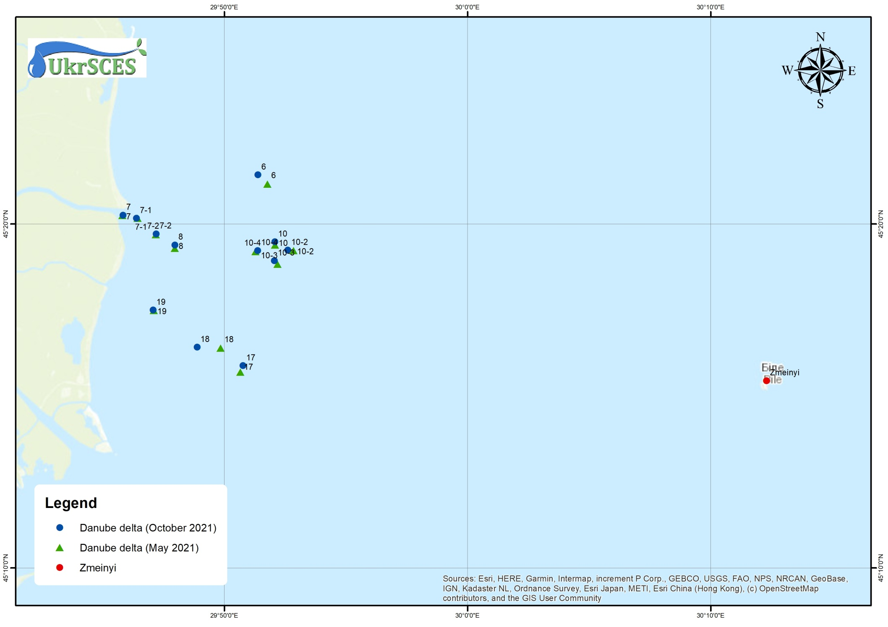
Figure 1 – BSIMAP stations of Ukraine in 2021

1.3 List of monitored parameters

List of monitoring parameters and number of performed samples in comparison with 2020 are presented in Table 2.

Table 2 - Samples numbers of Regional Ukrainian Monitoring Data in 2021/2020
Parameter | Samples numbers  (2021/2020) |  | Parameter | Samples numbers  (2021/2020) | Parameter | Samples numbers  (2021/2020)
Hydrochemicals (water) |  |  | Metals (water) |  | PAHs (water&bs)
Temperature | 84/62 |  | Fe | 48/24 | Naphthalene | 27/24 10/12
Salinity | 84/62 |  | Mn | 0/0 | Acenaphthylene | 27/24 10/12
pH | 84/62 |  | Zn | 48/24 | Fluorene | 27/24 10/12
O₂ | 48/48 |  | Co | 48/24 | Acenaphthene | 27/24 10/12
TSS | 48/86 |  | As | 48/24 | Phenanthrene | 27/24 10/12
Transparency | 40/24 |  | Hg | 48/24 | Anthracene | 27/24 10/12
BOD5 | 0/0 |  | Cu | 48/24 | Fluoranthene | 27/24 10/12
TOC | 48/24 |  | Cd | 48/24 | Pyrene | 27/24 10/12
H₂S | 0/0 |  | Pb | 48/24 | Benzo[a]antracene | 27/24 10/12
P(PO₄) | 84/62 |  | Ni | 48/24 | Chrysene | 27/24 10/12
P_{total} | 84/62 |  | Cr | 48/24 | Benzo(b)fluoranthene | 27/24 10/12
N (NH₄) | 84/62 |  | Al | 0/0 | Benzo(k)fluoranthene | 27/24 10/12
N (NO₂) | 84/62 |  | Other organic pollutants  (water) |  | Benzo[a]pyrene | 27/24 10/12
N (NO₃) | 84/62 |  | Phenols | 0/0 | Dibenzo[a,h]anthracene | 27/24 10/12
N_{total} | 84/62 |  | Detergents | 0/0 | Indeno(1,2,3-c,d)pyrene | 27/24 10/12
SiO₄ | 48/24 |  | TPHs | 24/0 | Benzo(ghi)perylene | 27/24 10/12
Chlororganic pesticides (water&bs) |  |  | PCBs total (water&bs) |  | Metals (bs*)
DDT |  | 48/24 24/12 | Ar1254 | 0/24 24/12 | Zn | 24/12
DDD |  | 48/24 24/12 | Ar1260 | 0/24 24/12 | Co | 24/12
DDE |  | 48/24 24/12 | PCB (34 ind.) | 48/23 24/23 | As | 24/12
Lindane |  | 48/24 24/12 |  |  | Hg | 24/12
α-HCH | 48/24 24/12 |  |  |  | Cu | 24/12
β-HCH | 48/24 24/12 |  |  |  | Cd | 24/12
HCB | 48/24 24/12 |  | Other organic pollutants (bs) |  | Pb | 24/12
Heptachlor | 48/24 24/12 |  | Phenols | 24/12 | Ni | 24/12
Aldrin | 48/24 24/12 |  | TPHs | 24/12 | Al | 24/12
Dieldrin | 48/24 24/12 |  | TOC | 24/0 | Fe | 24/12
Endrin | 0/0 0/0 |  |  |  | Cr | 24/12
* bs – bottom sediments

1.4 National institutions (laboratories) involved
Two institutions are involved in the Ukrainian monitoring system:
- UkrSCES - the Ukrainian Scientific Centre of Ecology of the Sea, Ministry of the Environment Protection (Department of Analytical Research and Organization of Monitoring, head Yuriy Denga)
- Odessa National I.I. Mechnikov University (Regional Centre for Environmental Monitoring and Ecological Studies, head Vladimir Medinets).

1.5 Data were reported to the Ministry of the Ecology and Natural Resources of Ukraine, Ministry of Transport of Ukraine and Permanent Secretariat of the BSC.

1.6 Financing assured by Ministry of the Ecology and Natural Resources of Ukraine and Ministry of Transport of Ukraine.

1.7 Size of funding 50 000 EURO from the Ministry of the Ecology and National Resources and 25 000 EURO from Ministry of Transport.

1.8 QA/QC – how is organized in the involved laboratories
The two laboratories: department of analytical research of UkrSCES and Regional Centre for Environmental Monitoring and Ecological Studies of Odessa National I.I. Mechnikov University which are involved in the international marine monitoring system.

Summary of quality control procedures routinely employed within the laboratory:

- Use of high quality analytical standards for instrument calibration.
- Use of high quality glassware, acids and other reagent and equipment.
- Routine calibration and adjustments of AAS and maintains of continuous records of these calibrations.
- Routine performance tests including complete procedural blank analyses and spikes.
- Use of certified reference material and performance of quality control chart.
- Use of replicate samples.
- Participation in Proficiency testing exercises

1.9 Names of authors of the annual report provided and names of those providing data:

Y. Denga, V. Komorin, Y. Oleinik, M. Nabokin, T Chuzhekova V. Medinets, O. Miasnikova, O. Leposhkin, A. Tityapkin

1.10 Participation in international conferences, seminars and meetings in 2021:

- Consultative forum of the EMODnet Chemistry, 3rd meeting of the project group, 2.02.2021.
- IODE-XXVI: Pre-Committee Working Group 8: The Future of ODIN, 22.02.2021.
- Ocean InfoHub project: meeting of the General Technical Working Group (WP2) on 30.03.2021.
- 26th session of the IOC Committee on the MOODI program, April 20-23.2021.
- Komorin V.M., Bolshakov V.M., Dykhanov Yu.M., Melnyk E.A. The main results of oceanographic research in the South Atlantic and the Atlantic sector of the Southern Ocean according to the data of the 2018-2020 seasons. Report at the X International Antarctic Conference , m. Kyiv. May 11-13.2021.
- Ninth International Scientific and Practical Conference "Computer Modeling and Control in Engineering and Technologies CMCET-2021", May 12-14, 2021, Kyiv, Ukraine.
- EMODnet Biology phase III – final meeting, 17.05.2021.
- EMODnet Biology phase IV – kick-off meeting, May 18-19. 2021.
- OBIS-EC-4 - interim meeting of SG-OBIS, 26.05.2021.
- Ocean InfoHub (OIH) and Ocean Data and Information System (ODIS) project meeting, 31.05.2021.
- 31st session of the IOC Assembly June 15-25.2021.
- Initial workshop of the EU4EMBLAS project, 30.06.2021.
- Tourism 4.0 for the Black Sea - Information webinar, July 7.2021.
- Development of Research and Innovation in the Black Sea for Shared Blue Growth in Sustainable Ecosystems, BRIDGE-BS project kick-off meeting, 12-13.07.2021.
- Online meeting of the ODINBLACKSEA project, 9th Steering Committee, 14.07. 2021
- International scientific and practical conference MODERN SCIENCE: PROBLEMS AND INNOVATIONS, August 23-25,2020, Stockholm, Sweden.
- BRIDGE-BS data portal and website design, online consultations, 3.09.2021.
- A. Tityapkin. On one method of a point localization in a polygon in relation to ecological and geographical problems. Report at the international scientific and practical conference "Intelligent Systems and Information Technologies" ISIT-2021 (Odesa, September 13-19.2021) within the framework of the "Digital Reality" forum.
- Participation in the conference "Practical water management on small and medium-sized rivers", Odesa, Ukraine, September 16-17.2021.
- Event "Black Sea Blue Business Seminar: further actions to support the business ecosystem", 4.10.2021.
- BRIDGE-BS - Meeting on work package 6 on mapping and analysis of interested parties for the implementation of "Living Labs", 12.10.2021.
- BRIDGE-BS - Intelligent observations and technologies to combat multi-stressors, stimulate innovation and support monitoring, 12.10. 2021.
- BRIDGE-BS, meeting on work package 3 "SUSTAINABILITY FOR A HEALTHY BLACK SEA ECOSYSTEM", 26.10.2021.
- S. Kovalyshyna, V. Ukrayinskyy, A. Tityapkin. Regarding complex methods of assessing the state of the marine environment. Report at the International scientific conference "Marine Ecosystems: Research And Innovations", (Odesa, State University "Institute of Marine Biology of the National Academy of Sciences of Ukraine" 27 29.10.2021).
- Krasota L.L. Bioassay of the Black Sea water quality on mussels larvae of early stages of development. Report at the International Scientific Conference "Marine Ecosystems: Research and Innovation" (October 27-29,2021).
- Rachynska O.V. Bioindication of the Black Sea environmental quality by the state of microphytobenthos. Report at the International Scientific Conference "Marine Ecosystems: Research and Innovation" (October 27-29,2021).
- Strategy of the blue economy for the Black Sea: contribution of Ukraine, 12.11. 2021.
- 2nd meeting of the advisory council - MARSPLAN-BS II, 16.11.2021.
- BRIDGE-BS - SeaDataNet online meeting, 18.11. 2021
- Regional conference of interested parties on the joint maritime agenda for the Black Sea, 22.11.2021.
- BRIDGE-BS, meeting on work package 1, 9.12.2021.
- BRIDGE-BS, workshop on pilot sites of the project, 10.12. 2021.
- EMODnet Chemistry V - Meeting of the full group, 13-14.12. 2021.
- IODE Steering Group for the ODINBlackSea Project, 10th session, 16.12. 2021.
- Online seminar "Final stage, Support of EU Framework Directive on marine strategy - regional monitoring system of Descriptor 1: Biodiversity, marine mammals and Descriptor 11: Marine noise in the Black Sea".
- ACCOBAMS international workshop on necropsy of cetaceans (June 2021).
- Session of the Black Sea Working Group of the General Commission for Fisheries in the Mediterranean Sea with a discussion on the death of cetaceans in fishing gear.
- SCGIS Ukraine 2021 seminar.
- ACCOBAMS international workshop on cetacean necropsy, October 2021.
- 14th meeting of the ACCOBAMS Scientific Committee (Monaco, November 22-26, 2021).
- XI International conference "Marine Mammals of the Holarctic".

1.11 Publications in 2021

- Большаков В.Н. Климат Одессы. (Справочник для любознательных) - Одесса «Астропринт», 2021 – 40 с. (у друку).
- Большаков В.Н., Сытов В.Н., Мартынюк М.О., Соколов Е.В. Простой метод определения прозрачности атмосферы / Другий Всеукраїнський гідрометеорологічний з’їзд 7-9 жовтня 2021, Одеса, Україна. Тези доповідей. – С. 153-154.
- Большаков В.Н. Простой способ регулирования солености Куяльницкого лимана /Другий Всеукраїнський гідрометеорологічний з’їзд 7-9 жовтня 2021, Одеса, Україна. Тези доповідей. – С. 199-200.
- Грандова М.О., Набокін М.В., Дядичко В.Г. (2021) Структура угруповання фіто- та зоопланктону шельфових вод північно-західної частини Чорного моря влітку 2019 року. // Морський екологічний журнал. – 2021. – №1, С. 34-44.
- Коморін В.М., Большаков В.М., Диханов Ю.М., Мельник Є.А. Основні результати океанографічних досліджень в Південної Атлантики та Атлантичному секторі Південного океану за даними сезонів 2018-2020 рр. Тези доповіді на Х Міжнародній антарктичній конференції, м. Київ. 11-13 травня 2021 року.
- Сєрга Е.М. «Вплив процесів у системі атмосфера-підстильня поверхня Північної Атлантики на регіональні клімати Східної Європи» (монографія). Тов. «505».Житомир.2021, 300 с.
- Снігірьова, А.О., Сілантьєв, С.О., Гончаров, О.Ю., та ін. Вплив екологічних факторів на мікроводорості псамону на прикладі Одеської затоки (Чорне море, Україна). Альгология. 2021. Вип. 31, №. 3. C. 228–248.
- Тітяпкин А.С., Український В.В. Щодо методів комплексної оцінки стану евтрофікації та якості морських вод // Матеріали Третьої Всеукраїнської науково-практичної конференції «Євроінтеграція екологічної політики України», Одеса, Одеський державний екологічний університет, 2021. – С. 57-64.
- Харитонова Ю. В., Набокін М.В., Дядичко В. Г. Багаторічні зміни біомаси Noctiluca scintillans ((Macartney) Kofoid & Swezy, 1921, Dinophyceae, Noctilucales) в Одеському та Дунайському районах Чорного моря як показника якості водного середовища // Морський екологічний журнал. – 2021. – №1, С. 79-85.
- Шурда К.Е. Сучасне уявлення про кліматичні ресурси, економіко-екологічна класифікація та використання. – Вісник науки, 2021, № 28, С. 20 -36.
- Dewaele, L., Gol’din, P., Marx, F. G., Lambert, O., Laurin, M., Obadă, T., & de Buffrénil, V. (2021). Hypersalinity drives convergent bone mass increases in Miocene marine mammals from the Paratethys. Current Biology: Volume 32, Issue 1, 10 January 2022, pp. 248-255.e2 https://doi.org/10.1016/j.cub.2021.10.065.
- Gol’din, P., Popov, D., Paiu, M., Vishnyakova, K., Tonay, A., Düzgüneş, E., Timofte, C., Meshkova, G., Panayotova, M., Öztürk, A. (2021). Cetacean Bycatch in The Black Sea: An Update from New Research and Testing Mitigation Measures. Document ACCOBAMS-SC14/2021/Doc20. pp. 1-10 p.
- J. Ivanchikova, K. Vіshnyakova PHOTO-IDENTIFICATION STUDY OF HUMPBACK WHALES (MEGAPTERA NOVAEANGLIAE) NEAR THE SOUTHERN ORKNEY ISLANDS DURING AUSTRALIAN SUMMER 2020-2021. X International Antarctic Conference, Kyiv, Ukraine, May 11-13, 2021, p.54
- Lebedenko, L., Nabokyn, M., Andreev, N., Kovalyshyna, S. The state of zooplankton communities in the lower Dniester area under the conditions of river regulation and actual climatic changes // Sustainable use and protection of animal world in the context of climate change. – 2021. – С. 55-64.
- Lazăr, L.; Boicenco, L.; Denga, Y.; Tolun, L.; Kurt, G.; Bişinicu, E.; Filimon, A.; Marin, O.; Oros, A.; Spînu, A.; Tabarcea, C.; Timofte, F.; Vlas, O.; Grandova, M.; Nabokin, M.; Oleinink, Y.; Kovalishina, S.; Chuzhekova, T.; Atabay, H.; Tan, İ.; Beken, C.; Aslan, E.; Partal, F. B.; Evcen, A.; Sahin, F.; Üstün, F.; Bat, L. ANEMONE Deliverable 2.2 "Anthropogenic Pressures and Impacts on the Black Sea Coastal Ecosystem"; Lazăr, L., Ed.; Editura CD Press, Romania: BUCUREȘTI, 2021.
- Lazăr L., Boicenco L., Todorova V., Denga Y., Atabay H., Kurt G., Paiu M., Tonay A., Abaza V., Bişinicu E., Coatu V., Filimon A., Galaţchi M., Harcotă G., Marin O. Oros A., Spînu A., Tabarcea C., Timofte F., Toţoiu A., Vlas O., Moncheva S., Stefanova K., Stefanova E., Slabakova N., Grandova M., Nabokin M., Oleinik Y., Kovalishina S., Tolun L., Aslan E., Kaman G, Beken C., Sahin F., Üstün F., Bat L., Timofte C., Paiu A., Cândea M. ANEMONE Deliverable 2.3 "Black Sea State of Environment Based on ANEMONE Joint Cruise"; Lazăr L., Ed.; Editura CD Press, Romania: BUCUREȘTI, 2021.
- Kovalyshyna, S., Chuzhekova, T., Grandova, M., et al. Ecological Conditions of the Lower Dniester and Some Indicators for Assessment of the Hydropower Impact. Applied Sciences. 2021. Vol. 11, No. 21. pp. 1-33. Режим доступу: https://doi.org/10.3390/app11219900
- Kovalishina, S.; Chuzhekova, T.; et al., E. ANEMONE Deliverable 2.1 "Impact of the Rivers on the Black Sea Ecosystem"; Lazăr L., Ed.; Editura CD Press, Romania: BUCUREȘTI, 2021.
- Kovalyshyna S.; Chuzhekova T.; Grandova M.; Onishchenko, E.; Zubcov, E.; Ukrainskyy V.; Goncharov O.; Munjiu, O.; Nabokin M.; Ene, A. Ecological Conditions of the Lower Dniester and Some Indicators for Assessment of the Hydropower Impact. Appl. Sci. 2021, 11, 9900. https://doi.org/10.3390/app11219900В
- Kovalyshyna S., Ukrainskiy V., Tityapkin A. Regarding Complex methods of Assessing the State of the Marine Environment / International scientific conference “Marine ecosystems: research and innovations”: Book of abstracts (27-29 October, 2021, Odessa, Ukraine) // Odessa-Istanbul, 2021. – P. 37.
- Kharytonova, Y. V., Dyadichko, V. G., Nabokin, M. V., Mgeladze, M. M., & Vadachkoria, P. A. Current state and long-term changes in the mesozooplankton community of the Ukrainian and Georgian parts of the Black Sea as indicators of its ecological status //Biosystems Diversity. – 2021. – Т. 29. – №. 1. – С. 47-58.
- Khokhlov, V., Serga, E., & Neodstrelova, L. (2021). Object ive selection of model run from regional climate models ensemble. Ukrainian Hydrometeorological Journal, (28), 29-36. https://doi.org/10.31481/uhmj.28.2021.03
- Khokhlov, V., E. Serga, L. Nedostrelova Using Ensemble of Regional Climate Models for Assessment of Future Climate in North-Western Coast of Black Sea. I 73 International Research-to-Practice Conference on 'Climate Services : Science and Education': Conference Proceedings. Odesa : Odessa State Environmental University, 2021. S.105-107.
- Сєрга Е.М., Хохлов В.М., Сєрга І.М. Регіональні процеси взаємодії атмосфери й океану у Північній Атлантиці. Тези доповідей другого всеукраїнського гідрометеорологічного з’їзду. Одеса. ОДЕКУ, 2021. С.130-141.
- B. A Krafft, G. Macaulay, G. Skaret, T. Knutsen, O. A Bergstad, A. Lowther, G. Huse, S. Fielding, P. Trathan, E. Murphy, S.-G. Choi, S. Chung, I. Han, K. Lee, X. Zhao, X. Wang, Y. Ying, X. Yu, K. Demianenko, V. Podhornyi, K. Vishnyakova, et al. Standing stock of Antarctic krill (Euphausia superba Dana, 1850) (Euphausiacea) in the Southwest Atlantic sector of the Southern Ocean, 2018–19, Journal of Crustacean Biology, Volume 41, Issue 4, December 2021, pp. ruab071, https://doi.org/10.1093/jcbiol/ruab071
- Krasota L. L. Bioassay of the Black Sea water quality on mussels’ larvae of early stages of development. // International scientific conference “Marine ecosystems: research and innovations” : Book of abstracts (27-29 October, 2021, Odessa, Ukraine). / Minicheva G.G., Snigirova A.A. (eds.) Odessa-Istanbul, 2021. – P. 38. – Режим доступу: http://www.blacksea-commission.org/Downloads/MarineEcosystems2021BoA.pdf.
- Alexander Matygin, Nadejda Andreev, Elena Zubcov, Antoaneta Ene, Ilya Trombitsky, Svetlana Kovalishina Assessing the impact of hydropower constructions and climate changes on functioning of dniester river ecosystem// Geological Society of America Abstracts with Programs, October 10, 2021. Vol 53, No. 6, 2021 doi: 10.1130/abs/2021AM-369095© Copyright 2021 The Geological Society of America (GSA), all rights reserved.
- Paiu, R.M., Panigada, S., Cañadas, A., Gol’din, P., Popov, D., David, L., Amaha Ozturk, A., Panayotova, M., Mirea-Candera, M. (2021). Deliverable 2.2.2. Detailed Report on cetacean populations distribution and abundance in the Black Sea, including proposal for threshold values. CeNoBS project - contract No 110661/2018/794677/SUB/ENV.C2. Constanta. 96 p.
- Semenova O. Analysis of the ecological condition of water and bottom substrates Ukrainian costal water bodies and the shelf zone of NWBS biotesting method on microalge . : Сб.науч. статей / Academician Leo Berg – 140 years: Collection of Scientific Articles Международная ассоциация хранителей реки „Eco-TIRAS” / Образовательный фонд им.Л.С. Берга / Бендерский историко-краеведческий музей. – Bendery: Eco-TIRAS, 21 march 2021 – Р.444 – 447.
- Olga Semenova. Analisys of the ecological conditions of water and bottom substrates of the lower dniester by the method of biotesting of microalgae: X-th International Conference of Zoologists "Sustainable use and protection of animal world in the context of climate changes" , Chisinau. - 2021. p. 93-98.
- Oros A., Coatu V., Tolun L., Atabay H., Denga Y., Damir N., Aslan E., Litvinova M., Oleinik Y., Kolosov V.). Hazardous substances assessment in Black Sea biota. Ceсretari Marine/Marine Research Journal. 2021.- 98 р.
- Rachynska О. V. Bioindication of the Black Sea environment quality by the state of microphytobenthos // International scientific conference “Marine ecosystems: research and innovations” : Book of abstracts (27-29 October, 2021, Odessa, Ukraine) / Minicheva G.G., Snigirova A.A. (eds.) Odessa-Istanbul, 2021. – P. 57. – Режим доступу: http://www.blacksea-commission.org/Downloads/MarineEcosystems2021BoA.pdf.
- Snigirova, A. O., Silantyev, S. O., Goncharov, O. Y., et al. Epipelic and epipsammic microalgae responses to environmental parameters: the Black Sea case study (the Gulf of Odesa, Ukraine). International Journal on Algae. 2021. Vol. 23, No. 3. (in press).
- Shurda K.E. Features of marine economic activities, classification and types in the context of marine nature-exploitation. – Економіка природокористування і сталий розвиток, 2021, 10 (29), у друку.
- Tityapkin А. On one method of a point localization in a polygon in relation to ecological and geographical problems / Міжнародна науково-практична конференція «Інтелектуальні системи та інформаційні технології» // Матеріали конференції. Одеса : Одеський державний екологічний університет, 2021. – С. 165-169.
- Terenko G.V., Alexander Krakhmalnyi (2021) Red tide of the Lingulodinium polyedrum (Dinophyceae) in Odesa Bay (Black Sea). Turkish Jornal of Fisheries and Aquatic Sciences. Vol. 22. (Preprint).
- Sawinykh-Paltseva L. V., Tretiak I. P. Exploring the possibilities of applying international experience in creating the first Blue Park in Ukraine. //International scientific conference “Marine ecosystems: research and innovations”: Book of abstracts (27-29 October, 2021, Odessa, Ukraine) – 38 P.
- Vladimir Ukrainskiy, Svitlana Kovalyshyna, Yuriy Denga, Anastasia Ivanova, Nadejda Andreev, Elena Zubcov, Antuaneta Ene. Concentration of organochlorine pesticides in water and bottom sediments of the Dniester river ecosystem: X-th International Conference of Zoologists "Sustainable use and protection of animal world in the context of climate changes" , Chisinau. - 2021. p. 109-112.
- K. Vishnyakova, J. Ivanchikova CETACEAN SPATIAL DISTRIBUTION NEAR THE SOUTHERN ORKNEY ISLANDS DURING ANTARCTIC KRILL FISHERY, AUSTRALIAN SUMMER 2020-2021. X International Antarctic Conference, Kyiv, Ukraine, May 11-13, 2021, p.55.
- Zinenko, O, Vishnyakova, K. A., Stoyanov, L., Gol’din, P. E. (2021). The northernmost record of the loggerhead sea turtle, Caretta caretta (Testudines, Cheloniidae), in the Black Sea with the review of the species occurrence in the region. Zoodiversity 55 (2): pp. 127-132.
- A.ZOTOV, O.MIASNIKOVA, O.ZOTOVA, M.PAVLOVSKA, A.DZHULAI. THE VARIABILITY OF COASTAL PHYTOPLANKTON OF THE NORTH-WESTERN BLACK SEA REGION, ISSN 2415-3680 (Online), ISSN 1810-7834 (Print), Вісн. Укр. тов-ва генетиків і селекціонерів, 2021, том 19, №1-2.

2 State of the Environment

Introduction
The system of marine environmental monitoring in 2021 was aimed at the study of the main environmental problems of the Black Sea - eutrophication of waters and the chemical pollution of the marine environment.
Sampling and analysis of sea water samples and bottom sediments were carried on board of the ship.
Directly in expedition conditions conducted a measurement of transparency of sea waters, as well as temperature and salinity from the surface to the bottom and carried out analysis of sea water samples for determination of dissolved oxygen, pH, ammonia, phosphate and nitrite nitrogen concentrations.
Carry out sampling and conservation of seawater samples by formalin for analysis of the number and species composition of phytoplankton.
A zooplankton catches by Jedi net.
At the station of sampling of the bottom sediment was carried gathering and preservation by formalin benthic organisms (meiobenthos, macrozoobenthos and microphytobenthos).
Carry out sampling of seawater from the surface horizon for the analysis of photosynthetic pigments.
In the laboratories of the Centre was performed:

- Scientific analysis of meteorological conditions and hydro physical regime of the study areas.
- Chemical analysis of seawater samples for determination of suspended matter (TSS), nitrate, total nitrogen and phosphorus.
- Analysis of sea waters, bottom sediments samples for determination of priority pollutants (TPHs, Corg., Phenols, OCPs, PCBs, PAHs and Trace metals).
- Granulometric analysis of bottom sediments.
- Determination of photosynthetic pigments (chlorophyll a, b, c, feofityn and carotenoids).
- Analysis of the number and species composition of phytoplankton in seawater samples.
- The study of species composition and biomass of zooplankton.
- Study of the number and species composition of benthic communities (macrozoobenthos, macrophytobenthos and microphytobenthos, meiobenthos).

Analysis of the level of pollution in the marine environment was implemented compared with current standards of maximum allowable concentrations (MAC), adopted in Ukraine and in the European Union.
For evaluation of the integral quality of sea water and sediment was used developed in UkrSCES in the 2009 draft "Environmental quality standards of the marine environment".

  - Material and methods

Main equipment:

- GC/MS Agilent
- GC with capillary column and ECD, “Agilent”
- Graphite Furnace AAS “ZeeNit”
- Flame AAS “Spectr-AA-220” – “Varian”
- IR Fourier Spectrophotometers
- UV-VIS spectrophotometer for determination of BOD-5 and COD
- pH-meters: “pH-530”
- laboratory balances:
  - “BR110D”, BR 211D, both “Sartorius” and E 04130 – “OXAUS”

Danube delta area

During 2021 UkrSCES performed 2 expeditions according Programme of marine environmental monitoring of the deep-water navigation channel of the Danube - Black Sea (via arm Bystriy).
Expeditionary study conducted in spring (May) and autumn (October)2021.

2.2 Hydrophysical characteristic of the marine part of the Danube Delta in May 2021

Figure 2.1 shows a picture of the visual range of the AERONET system, which characterizes the spread of the waters of the Danube discharge into the Black Sea. The river waters (light in color) actively spread in the east and further in the northeast direction for a distance of 10-15 miles, and were less clearly traced by color at a distance of 20-25 miles.
The thermal state of coastal waters was characterized by coastal upwelling and the corresponding access to the surface of cold deep waters under the influence of westerly winds.

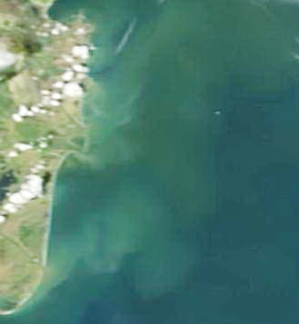 | 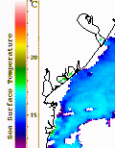 | 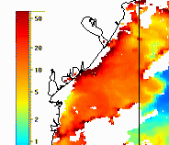
а) | b) | c)
Figure 2.1 – Thermal state of coastal waters: a) snapshot of the AERONET visual range system; b) thermal imaging of the water surface; c) distribution of chlorophyll-a according to MODIS satellite data, May 15, 2021

However, the data of expedition observations show an excess of surface temperatures on the western coastal shelf (16-18 ºС) over the thermal conditions of the eastern regions of the landfill (11-13 ºС, Fig. 2.2 a). In this case, the contribution of a different sign and in a narrower coastal zone is made by warmer river waters spreading in the surface layer. In the bottom layers, at depths of more than 15 meters, the water temperature is low and very uniform (8-9 ºС, Fig. 2.2 b).

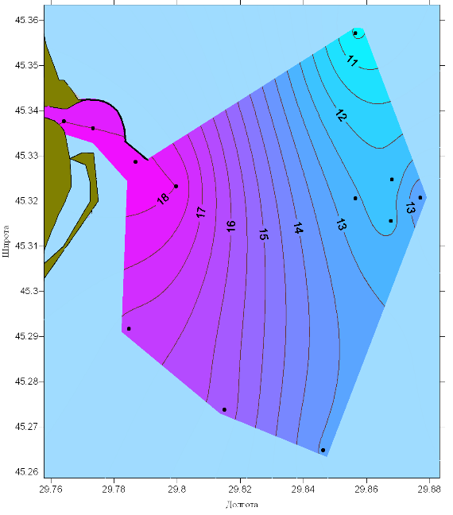 | 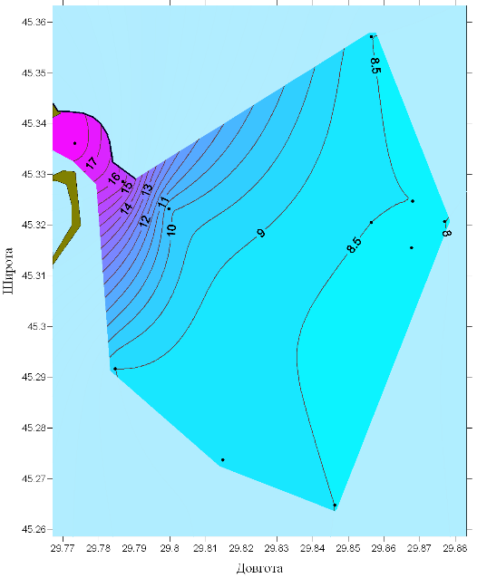
a b
Figure 2.2 - Distribution of water temperature (° C) on the surface (a) and bottom (b) horizons
at the Danube landfill, May 15, 2021
The distribution of the salinity of the water in the surface layer increased uniformly from almost zero values in the coastal region of the channel to 12-14 ‰ in the eastern part of this sea area (Fig. 2.3 a). In the bottom layer (Fig. 2.3 b), the water was 2-8 ‰ saltier than the surface waters within the channel and essentially homogeneous at depths of more than 15 meters (16-18 ‰).

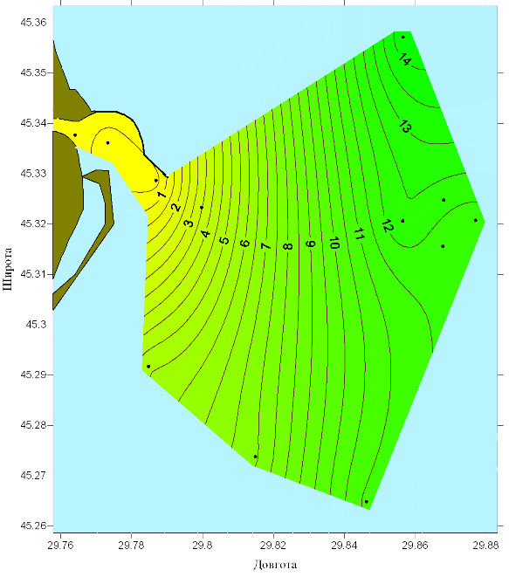 | 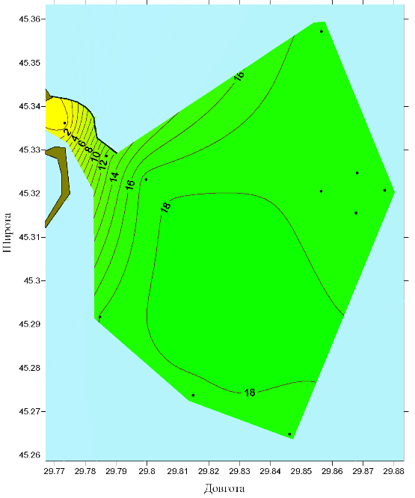
a b
Figure 2.3 - Distribution of seawater salinity (‰) on the surface (a) and bottom (b) horizons. at the Danube landfill, May 15, 2021

The nature of distribution of the conditional density of sea water on the surface and in the bottom layer (Fig. 2.4) repeats the distribution of salinity. Bottom waters of deep areas are extremely homogeneous (13.5-14.0 conventional units, Fig. 2.4 b).

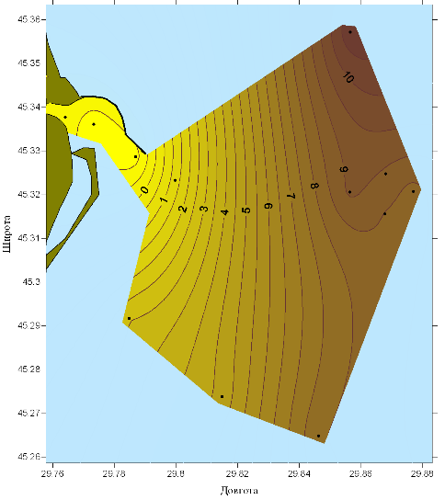 | 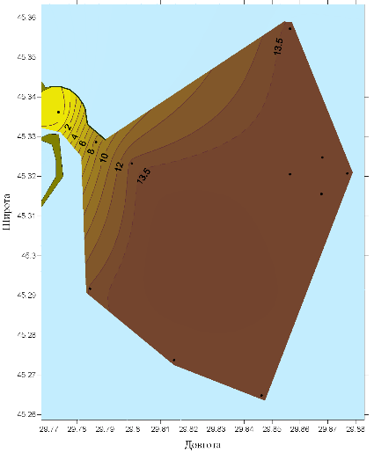
Figure 2.4 – Spatial distribution of conditional water density at the Danube landfill in: a) surface and b) bottom layers, May 15, 2021

The transparency of the surface layer of water, traditionally determined by the Secchi transparency disc, was low. The transparency varied from 2.4 m in the east to 0.5 m in the area of the mouth of the approach channel of the Bystry branch (Fig. 2.5 a).

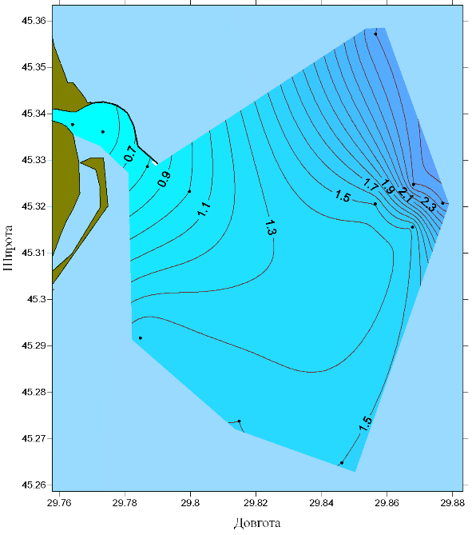 | 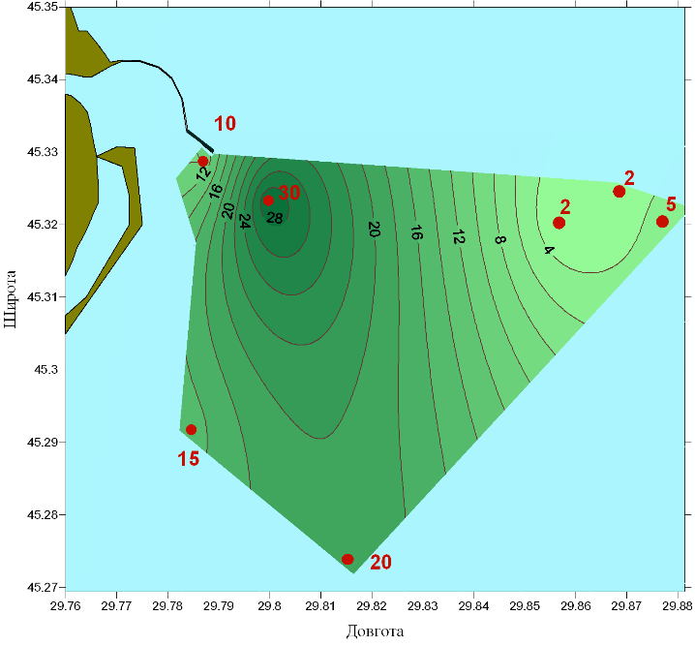
Figure 2.5 – Spatial distribution of: a) water transparency of the surface layer;
b) secondary silting of bottom sediments, May 15, 2021

The distribution of secondary siltation of the water area (silting) is shown in Figure 2.5 b. At the traverse of the end of the pier of the approach channel, the silting was 10 mm. A little more marine, on the slope of the coastal shelf, the precipitation reached an absolute maximum of 30 mm. The amount of silting was high at stations 18 and 19, 20 mm and 15 mm, respectively, and insignificant in the area of dumping (stations 10-4, 10 and 10-2, respectively – 2 mm, 2 mm and 5 mm).

2.3 Hydrophysical characteristic of the marine part of the Danube Delta in October 2021

The survey of the Danube landfill was carried out at the end of October during the continuation of the period of autumn-winter cooling of the water column.

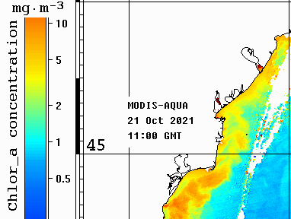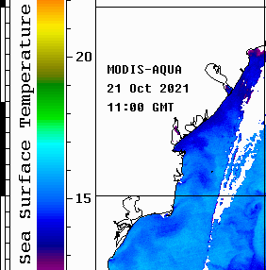
a | b

Figure 2.6 – Distribution of a) water temperature, b) chlorophyll-A concentration in the surface water layer of the western half of the northwestern shelf on October 21, 2021. MODIS-AQUA satellite data

The work was performed in two stages due to adverse weather conditions - on October 23 and 26, 2021.
In the period before the shooting, the water surface temperature, according to satellite observations, reached 14.5-16 ºС (Fig. 2.6 a), the concentration of chlorophyll-A did not exceed 5 mg.m-³ (Fig. 2.6 b). Under the influence of south-westerly winds, the coastal waters of the river discharge actively spread in the north-east direction, while colder jets of river waters were clearly distinguished. Seaward, already outside the boundaries of the intended landfill, water flows changed their directions to the south and southeast under the influence of the shelf thermohaline circulation of a cyclonic nature. It was not possible to obtain satellite information during the work period due to significant cloudiness over the entire western half of the Black Sea. After the works were completed, satellite observations showed a decrease in water temperature by approximately 1 ºС (to 13.5 - 15 ºС, Fig. 2.7 a). The content of chlorophyll-A on the traverse of the Kili delta remained the same, and to the south and north of it it locally increased to 8-12 mg.m-3 (Fig. 2.7 b).

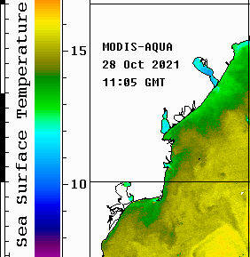 | 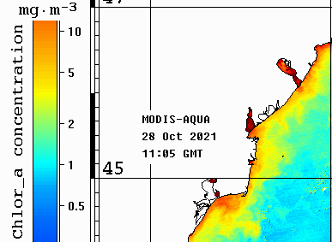
a | b
Figure 2.7 – Distribution of a) water temperature, b) chlorophyll-A concentration in the surface water layer of the western half of the northwestern shelf on October 28, 2021. MODIS-AQUA satellite data

The surface water temperature at the landfill, according to field observations, varied by no more than 12,5-15 ºС (Fig. 2.8 a). It varied from 13 to 13,5 °C within the bar section of the shipping lane and gradually increased to 15 °C near the eastern borders of the landfill. The temperature of water in bottom horizons was on average 0,2-0,3 ºС higher than on the surface, and the spatial distribution exactly repeated the surface one (Fig. 2.8 b).
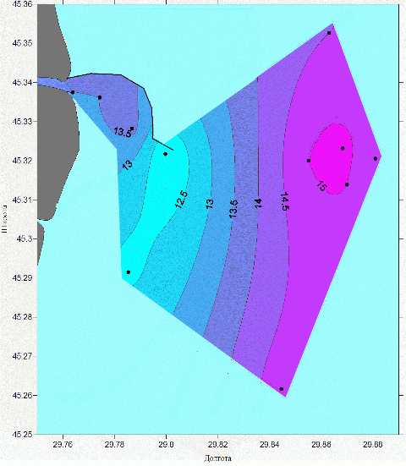 | 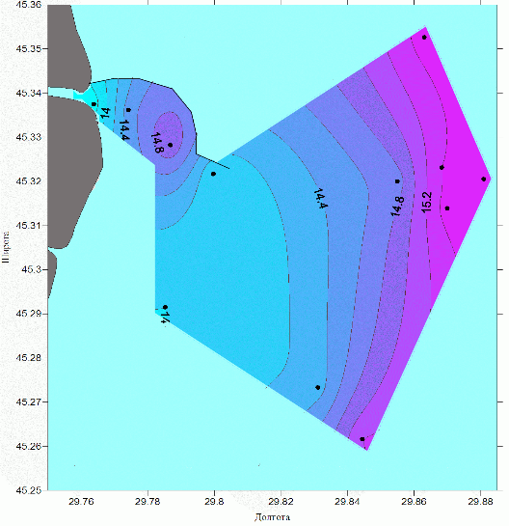
a | б
Figure 2.8 - Distribution of water temperature a) on the surface, b) on the bottom horizons
in October 23, 26, 2021
The climatic October water temperature estimate for the last 30 years for this area is 12,21 °C, which is approximately 1,5 °C lower than the average temperature estimate for the landfill. And if we take into account that the landfill was completed at the end of the month, then we can assume an approximate correspondence to the climatic value.
The most desalinated waters (0-5 ‰) were observed on the surface in the area of the shipping channel, further towards the sea intensive mixing and salinization of river waters occurred (Fig. 2.9 a). Thus, if the difference between the salinity of the bottom layer and the salinity of water on the surface (station 8, depth 12 m) was 14,1 ‰, then the difference between the surface and the bottom in the area of the soil dump, with depths of about 20 m, did not exceed 1 ‰.
Bottom waters mixed most intensively already in the coastal part of the Danube seaboard, and in the open part, outside the shallow shelf zone, the salinity of bottom waters varied within narrow limits – 17,0-17,9‰ (Fig. 2.9 b).

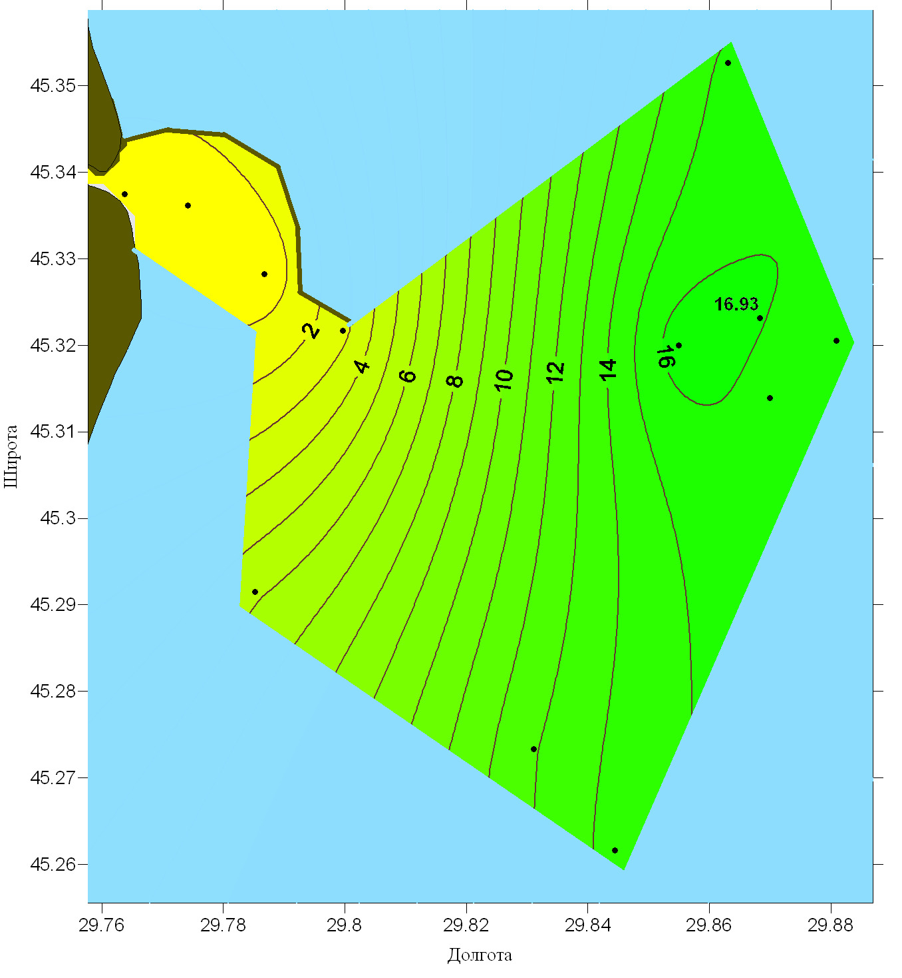 | 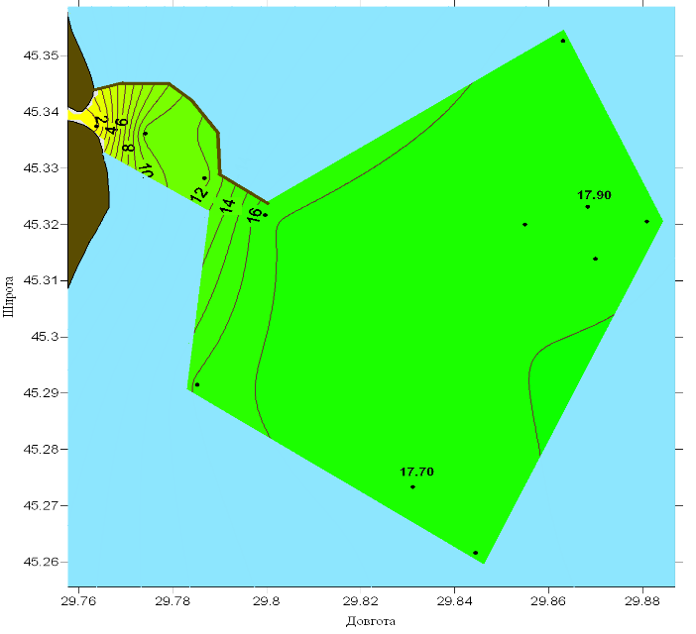
a | b
Figure 2.9 - Distribution of water salinity in October: a) on the surface; b) on bottom

At all stations, the transparency of the surface layer of water was measured using a Secchi disc. Within the shallow bar section of the navigable channel, the transparency of the river waters that came out did not exceed one meter (Fig. 2.10 a). Water transparency was low in other areas of the landfill, where intense mixing of river and sea waters occurred under the influence of strong winds. The maximum transparency of 2,6 m was noted at station No. 6.
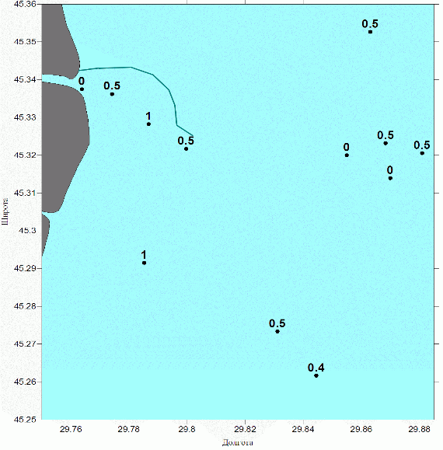
Sampling of bottom sediments was carried out in order to determine their fresh accumulation in the coastal water area and conduct hydrochemical analysis in the shore laboratory. The distribution of the thickness of secondary siltation (silting) is presented in Figure 2.10 b.
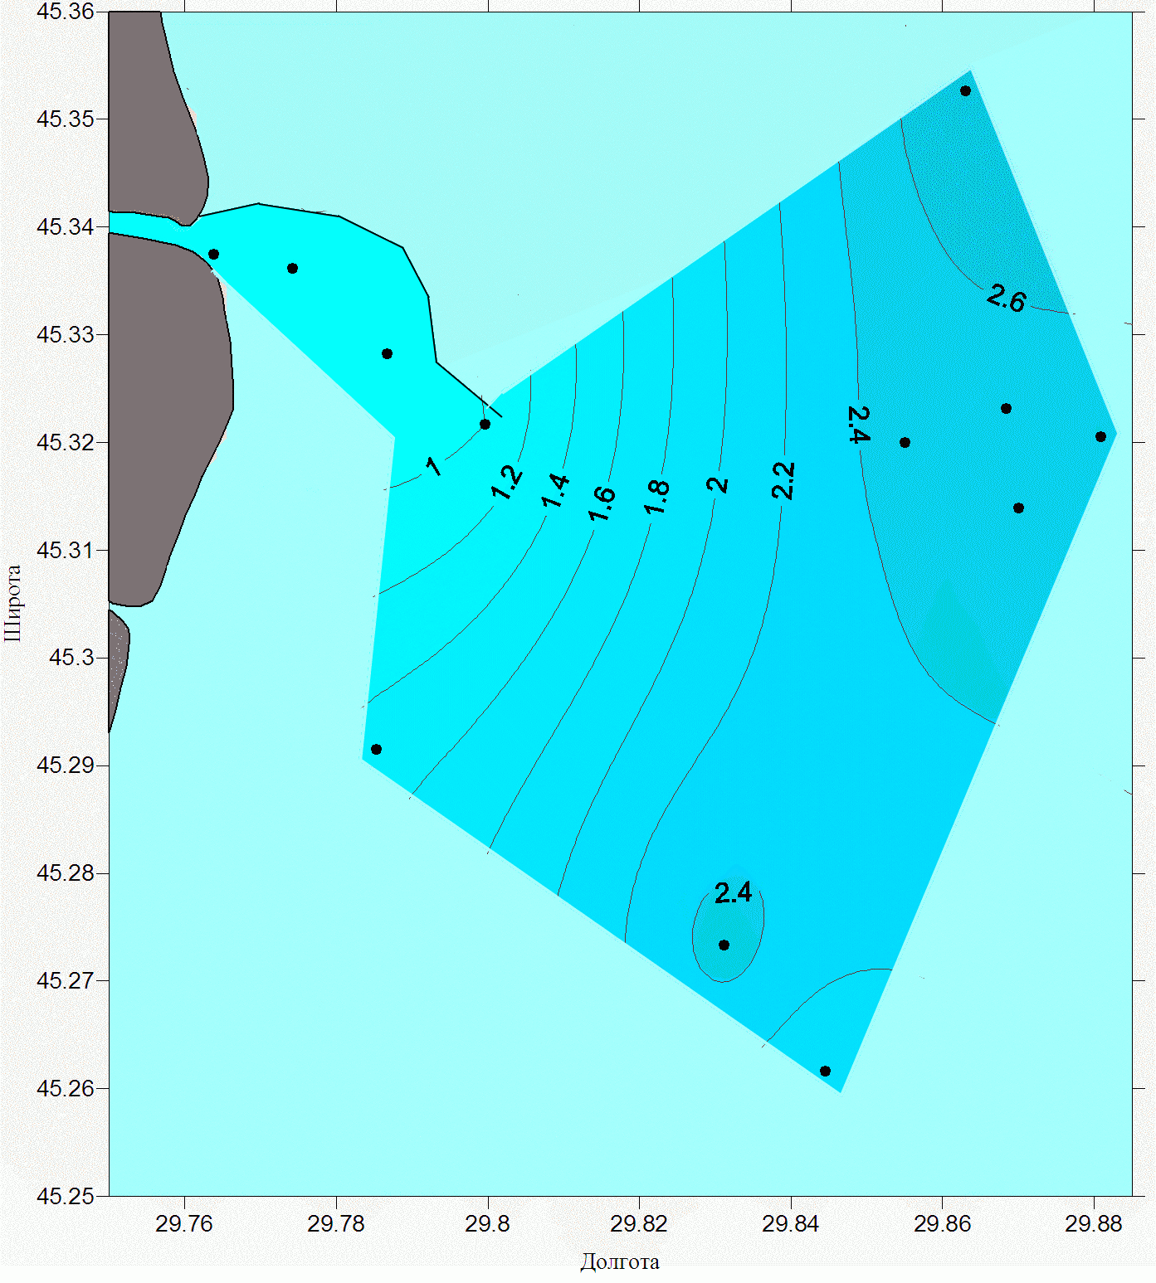
a b
Figure 2.10 - Distribution of the transparency of the near-surface water layer (a) according to the data of the Secchi disc, and the thickness of secondary siltation (b) on October 23, 26, 2021

Results of hydro chemical investigations in Ukrainian waters in 2021

General parameters – T⁰C, Salinity, pH, Oxygen, BOD₅, TSS

Range of variations of general parameters in UA national waters in 2021 are presented in Tables 2.1 – 2.2.
Table 2.1 - Range of variations of general parameters in the surface layer of UA national waters in 2021
 | T  ⁰C | Salinity  ⁰/₀₀ | pH | O₂  µM | BOD₅  µM | TSS  mg/L
Danube delta (May 2021)
Min | 10.4 | 0.30 | 8.10 | 224.1 |  | 4.60
Max | 18.2 | 14.4 | 8.52 | 317.2 |  | 54.2
Average | 14.9 | 7.60 | 8.30 | 275.3 |  | 20.8
Danube delta (October 2021)
Min | 11.8 | 0.40 | 7,97 | 169.1 |  | 6.22
Max | 15.2 | 16.6 | 8.26 | 342.8 |  | 20.5
Average | 13.8 | 9.70 | 8.10 | 260.1 |  | 13.6
Island Zmeinyi 2021
Min | 10.0 | 15.0 | 8.10
Max | 27.2 | 18.4 | 8.50
Average | 19.8 | 16.9 | 8.30

Table 2.2 - Range of variations of main chemical quality parameters in the bottom layer of UA national waters in 2021
 | T  ⁰C | Salinity  ⁰/₀₀ | pH | O₂  µM | BOD₅  µM | TSS  mg/L
Danube delta (May2021) ¹
Min | 8.00 | 0.30 | 8.04 | 111.6 |  | 0.60
Max | 18.0 | 17.8 | 8.46 | 332.5 |  | 54.8
Average | 10.9 | 14.3 | 8.20 | 219.1 |  | 20.2
Danube delta (October 2021) ²
Min | 13.7 | 0.50 | 7.10 | 148.4 |  | 2.93
Max | 15.5 | 17.9 | 8.20 | 276.9 |  | 18.0
Average | 14.8 | 15.1 | 8.00 | 233.6 |  | 10.3
Island Zmeinyi ³ 2021
Min | 10.1 | 15.3 | 8.10
Max | 26.3 | 18.3 | 8.40
Average | 19.5 | 17.1 | 8.30
¹ On the depth 4,0 - 25,0 m
² On the depth 4,5 m - 23,5 m
³ On the depth 8 m
In May the values of pH in the Danube Delta in surface layer of water were minimal - 8,10 (рН units) at station 10 and maximal - 8,52 (рН units) at station 7-2 (Tab. 2.1, Fig. 2.11 a). In the bottom layer the minimum pH value (8,04 pH units) was recorded at a depth of 9 m in the area of station 19, 8 and the maximum pH (8.46 pH units) at station 7-1 in the shipping channel (Tab. 2.2, Fig. 2.11 b).

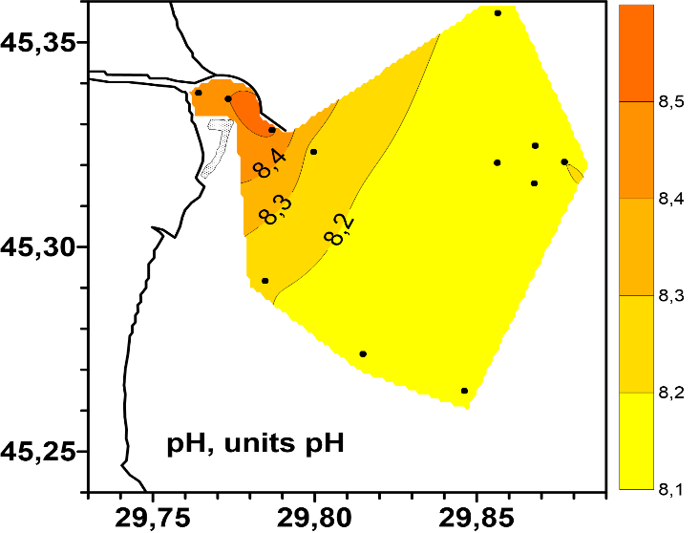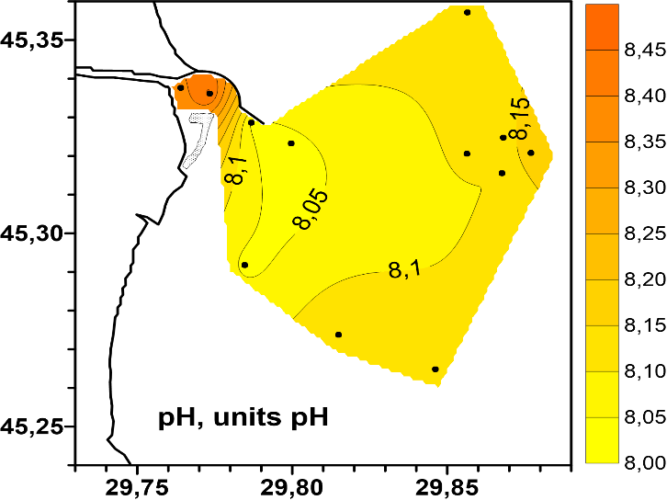
а b
Рисунок 2.11 — Spatial distribution of pH (units of pH) in the surface a) and bottom b) layers of the water on the seaside of the aim Bystriy in May 2021
The concentrations of dissolved oxygen in the surface layer of water varied from 224,1 to 317,2 µM (Tab. 2.1). The maximum of oxygen in the Danube delta area in May was registered at station 7, minimum – at station 10-4 (Fig. 2.12 a).
The concentrations of dissolved oxygen in the bottom layer of water varied from 111,6 to 332,5 µM (Tab. 2.2). The maximum of oxygen in the Danube delta area in May was registered at station 7-1, minimum – at station 18 (Fig. 2.12 b).

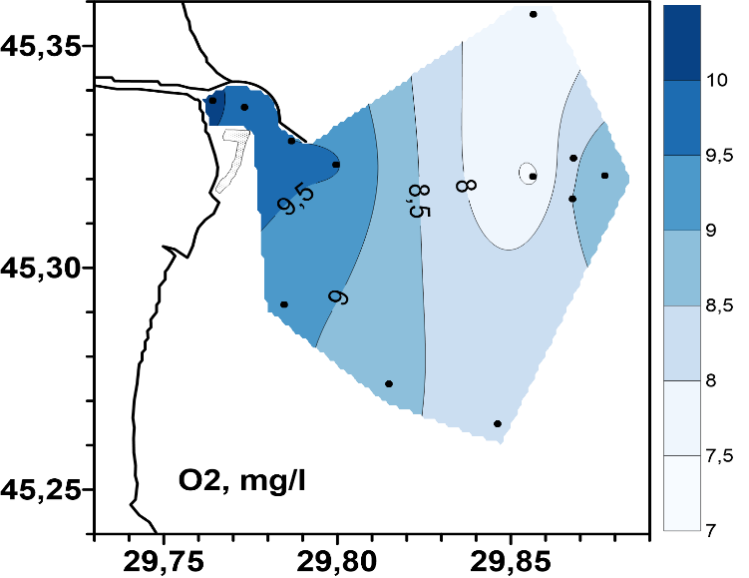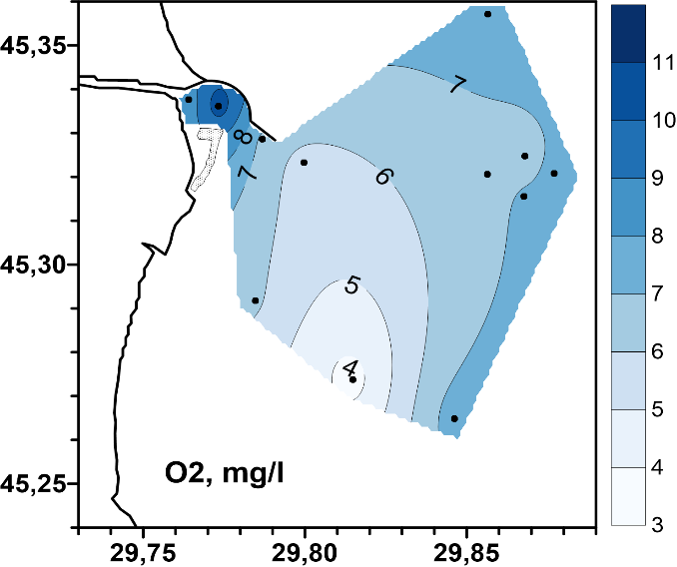
а b
Figure 2.12 - Spatial distribution of dissolved oxygen (absolute content)
in the surface a) and bottom b) layers of water on the seaside of the aim Bystriy in May 2021

The range of variation of dissolved oxygen in the surface layer of water ranged from 105 to 154 % saturation (Fig. 2.13 a), which indicates an improvement in the oxygen regime in the study area. Hypoxia phenomena that are characteristic of the bottom waters of the study area in May 2021 were not detected. The minimum value of water oxygen saturation in the bottom layer (49,3 %) was recorded at station 18 in the south-eastern part of the landfill (Fig. 2.13 b).

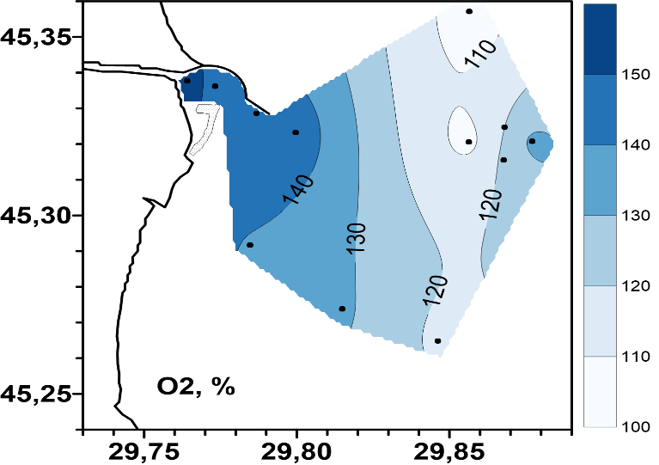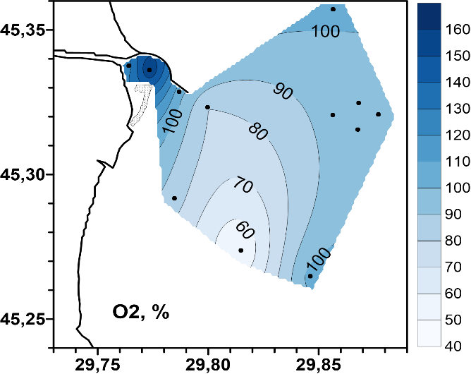
а b
Figure 2.13 - Spatial distribution of dissolved oxygen (% saturation)
in the surface a) and bottom b) layers of the water on the seaside of the aim Bystriy in May 2021

Concentrations of suspended solids were maximum at stations 7 - 7-2 of the shipping channel. The maximum of TSS (54.8 mg/l) was recorded in the bottom layer of station 7-1 (Table 2.2, Fig. 2.14 b).

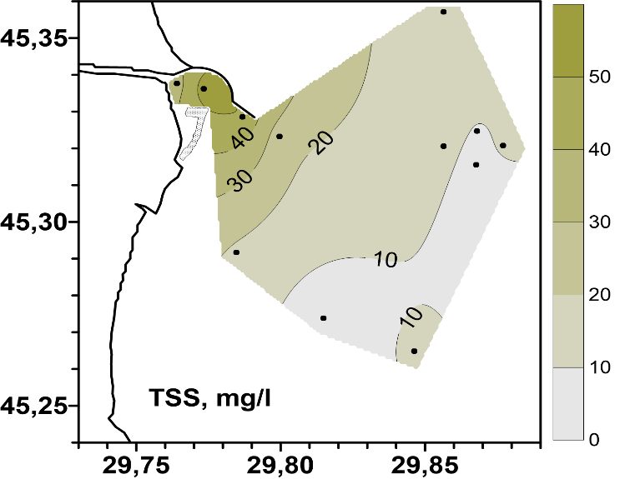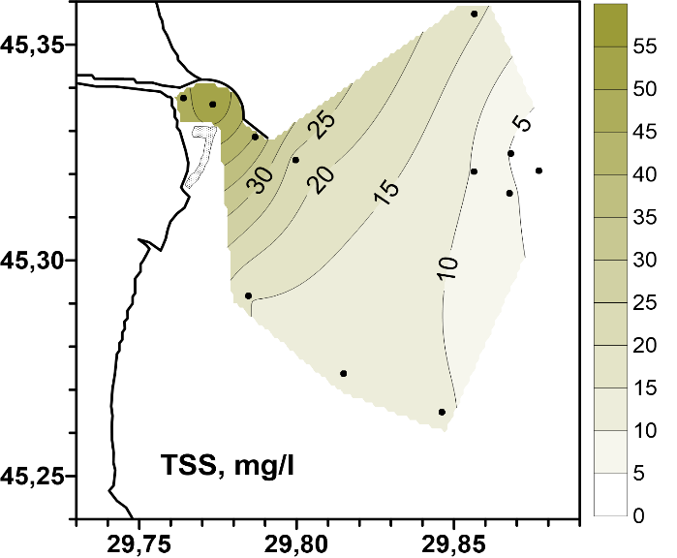
а b
Figure 2.14 - Spatial distribution of total suspended solids in the surface a) and the bottom b) layers of the water on the seaside of the aim Bystriy in May 2021

In October the values of pH in the Danube Delta in surface layer of water were minimal – 7,97 (рН units) at station 7-1 and maximal - 8,26 (рН units) at station 8 (Tab. 2.1, Fig. 2.15 a). In the bottom layer the minimum pH value (7,11 pH units) was recorded at a depth of 4,3 m in the area of station 7-1 in the shipping channel and the maximum pH (8,26 pH units) at station 10 (Tab. 2.2, Fig. 2.15 b).

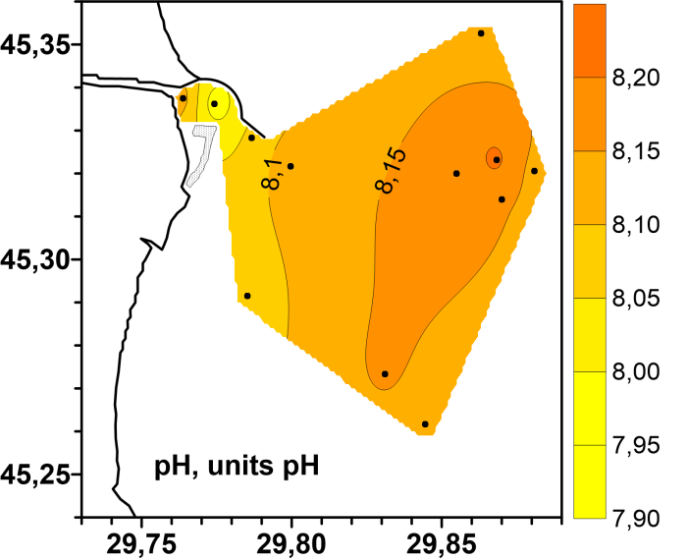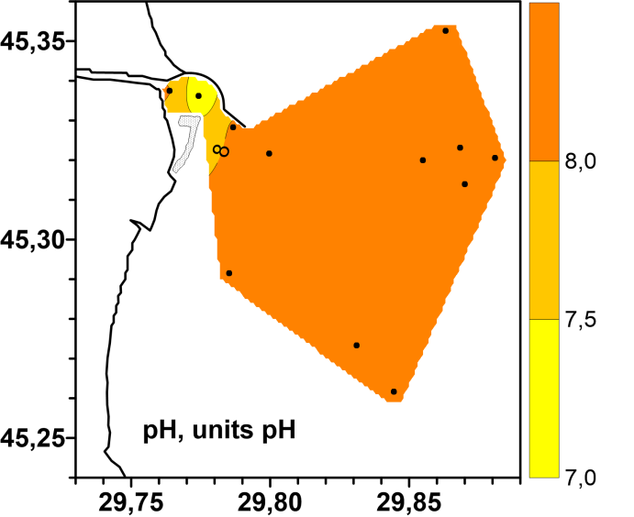
а b
Рисунок 2.15 — Spatial distribution of pH (units of pH) in the surface a) and bottom b) layers of the water on the seaside of the aim Bystriy in October 2021
The concentrations of dissolved oxygen in the surface layer of water varied from 169,1 to 342,8 µM (Tab. 2.1). The maximum of oxygen in the Danube delta area in October was registered at station 7, minimum – at station 10-4 (Fig. 2.16 a).
The concentrations of dissolved oxygen in the bottom layer of water varied from 111,6 to 332,5 µM (Tab. 2.2). The maximum of oxygen in the Danube delta area in October was registered at station 10-3, minimum – at station 10-2 (Fig. 2.16 b).

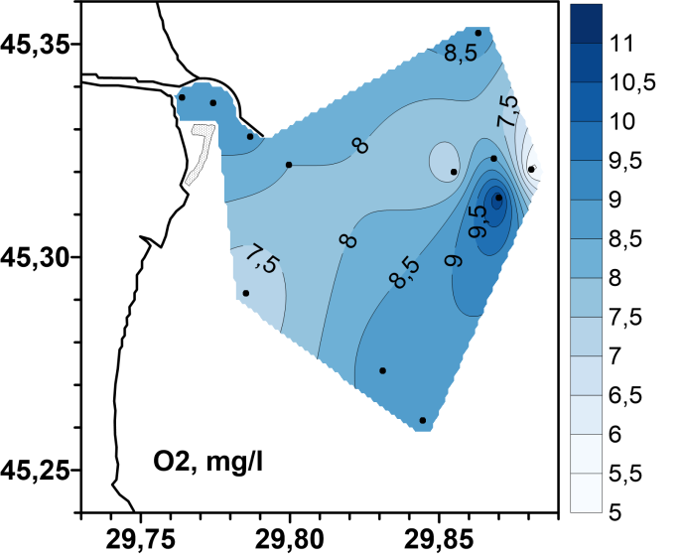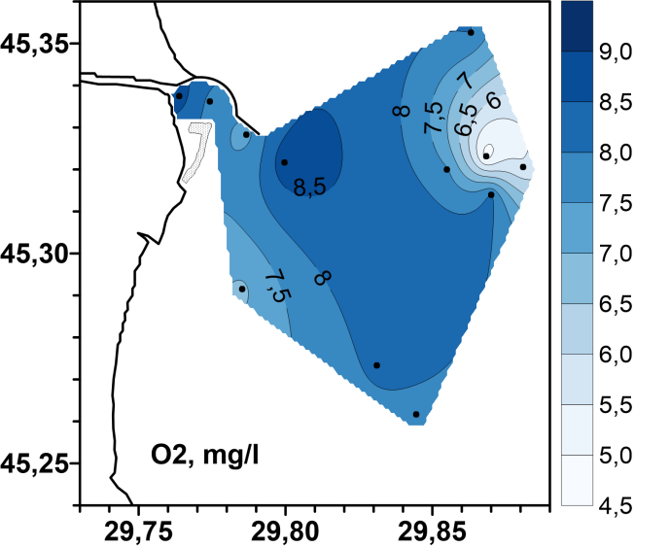
а b
Figure 2.16 - Spatial distribution of dissolved oxygen (absolute content)
in the surface a) and bottom b) layers of water on the seaside of the aim Bystriy in October 2021

The range of variation of dissolved oxygen in the surface layer of water ranged from 67,9 to 122 % saturation (Fig. 2.17 a), which indicates good oxygen regime in the study area. Hypoxia phenomena that are characteristic of the bottom waters of the study area in October 2021 were not detected. The minimum value of water oxygen saturation in the bottom layer (52,9 %) was recorded at station 10 in the damping area (Fig. 2.17 b).

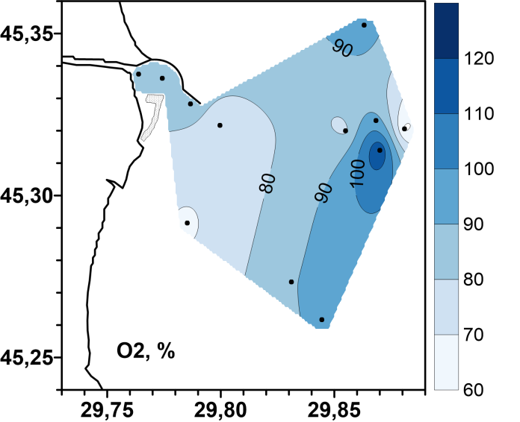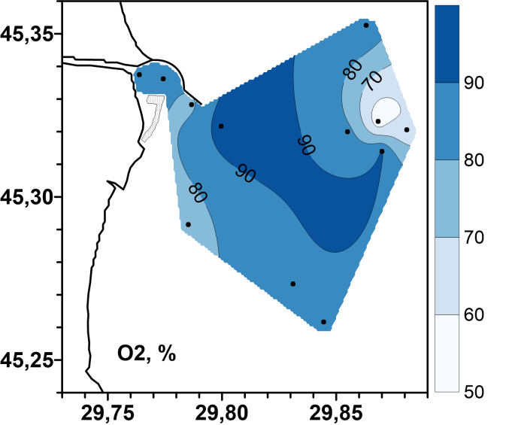
а b
Figure 2.17 - Spatial distribution of dissolved oxygen (% saturation) in the surface a) and bottom b) layers of the water on the seaside of the aim Bystriy in October 2021

The maximum of suspended solids was recorded in surface water at station 17 (20,5 mg/l). In the bottom layer higher concentration of TSS (18.5 mg/l) in October was fixed at station 8 (Table 2.2, Fig. 2.18 b).

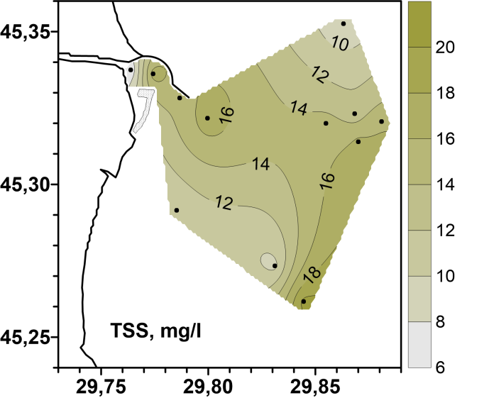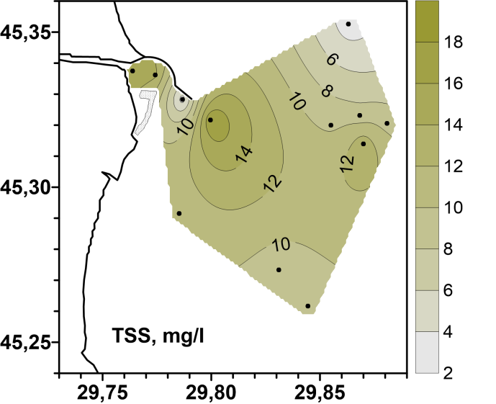
а b
Figure 2.18 - Spatial distribution of total suspended solids in the surface a) and the bottom b) layers of the water on the seaside of the aim Bystriy in October 2021

3 Pollution of marine environment

3.1 ECOLOGICAL CONDITION OF SEAWATER BY CONTENT OF POLLUTANTS

The status of seawater and bottom sediments was assessed for such pollutants as: trace metals (TM), organochlorine pesticides (OCPs), polychlorinated biphenyls (PCBs) and polyaromatic hydrocarbons (PAHs).
The pollution factor (Kz) was used to assess the level of pollution.
Kz reflects the concentration of all pollutants of the same type in a certain period of time in a given area. This factor is invented as the sum of the ratios of the concentration of each pollutant to its maximum permissible concentration, in accordance with EU Directive 2013/39/EU (MAC-EQS), or the maximum permissible concentration according to Ukrainian legislation (MPC), to the number of measurements performed in a given period of time. The accuracy of displaying the state of the regon using this factor depends on the number of monitoring stations in the study area and the number of observations over the past period of time. The overal assessment of the ecological condition of water or bottom sediments in the study area is determined by the worst assessment of the group of pollutants.

Calculation formulas:

Kz
$$CR=\frac{C_{mon}}{C_{Treshold}}$$
$$Kz=\frac{1}{n}\sum_{i=0}^{n}{CR_{i}}$$

Where: CR is contamination ratio

The ecological condition of sea water with the help of Kz is estimated:

- Very good when Kz is less than 0,5;
- Good when Kz from 0,5 to 1,0;
- Satisfactory when Kz from 1,0 to 2,5;
- Bad when Kz from 2,5 to 5,0;
- Very bad when Kz is more than 5,0.

The north-western part of the Black Sea (NWP of BS) is assessed by the open sea distribution areas and by water bodies of certain “Transitional Waters” and “Coastal Waters areas” in accordance with the Water Framework Directive 2000/60/EC (WFD) (Figure 3.1).

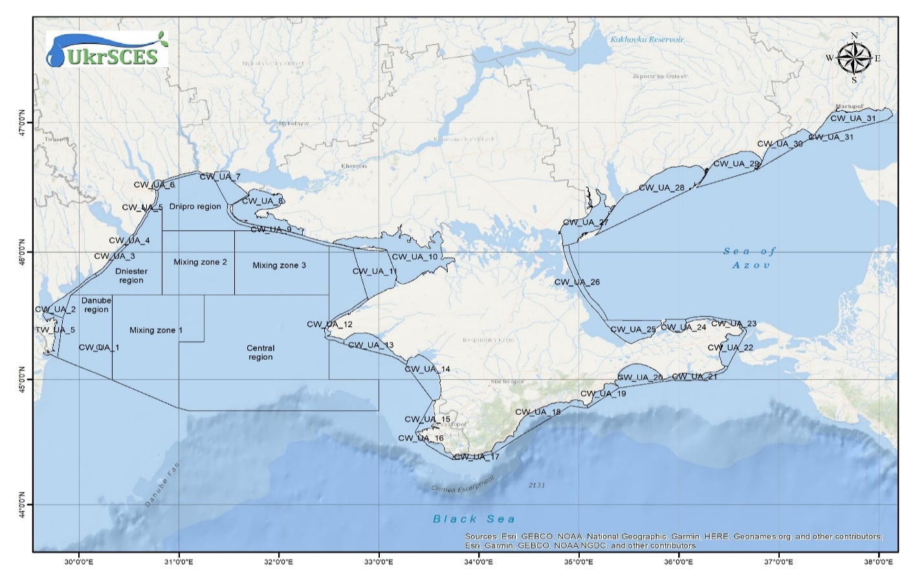Figure 3.1 - Map of areas of the marine environment of the NWP of BS

Table 3.1 shows the coordinates of the stations.

Table 3.1 Coordinates of sampling stations in 2021
The name of the scientific topic, project, flight | Conventional designation of the station | Longitude, ^{о} | Latitude, ^{о}
Danube district
Danube-BS | St. 6
Danube-BS | St. 10 | 29.86648 | 45.31982
Danube-BS | St. 10-2 | 29.87453 | 45.31712
Danube-BS | St. 10-3 | 29.8693 | 45.31393
Danube-BS | St. 10-4 | 29.85655 | 45.32003
Danube-BS | St. 17 | 29.85885 | 45.25188
Danube-BS | St. 18 | 29.82222 | 45.27345
TW5
Danube-BS | St. 7-1 | 29.77417 | 45.33583
Danube-BS | St. 7-2 | 29.78667 | 45.32833
Danube-BS | St. 19 | 29.79010 | 45.29167

3.1.1 Ecological assessment of the state of sea water for the content of toxic metals

Table 3.2 and Figure 3.2 show Kz values for mercury (Hg), cadmium (Cd), lead (Pb), nickel (Ni) and Kz TM in the surface and bottom layer of water according to 2021 data by district. The environmental assessment was carried out in accordance with EU directive 2013/39/EU (MAC-EQS).

Table 3.2 Kz TM of sea water by district in 2021.
Area | layer | Кз ТМ | Кз Cd | Кз Hg | Кз Pb | Кз Ni
TW5 | surface | 0,13 | 0,38 | 0,00 | 0,07 | 0,07
ShW_UA1 | surface | 0,10 | 0,28 | 0,05 | 0,03 | 0,04
TW5 | bottom | 0,10 | 0,30 | 0,00 | 0,06 | 0,04
ShW_UA1 | bottom | 0,07 | 0,19 | 0,05 | 0,01 | 0,02

Table 3.2 and Figure 3.2 show in 2021, Kz TM in all districts correspond to a very good ecological condition.

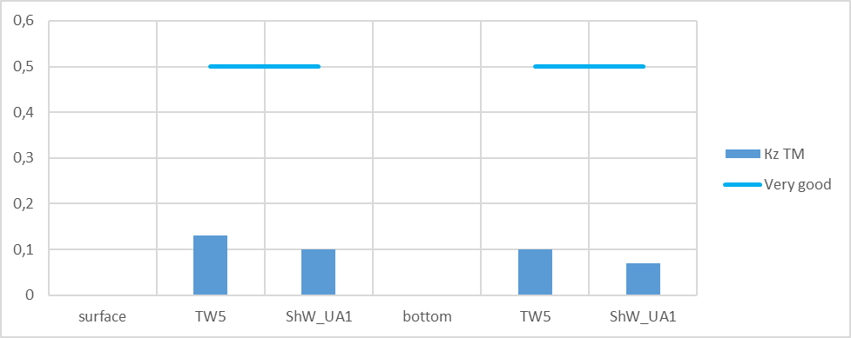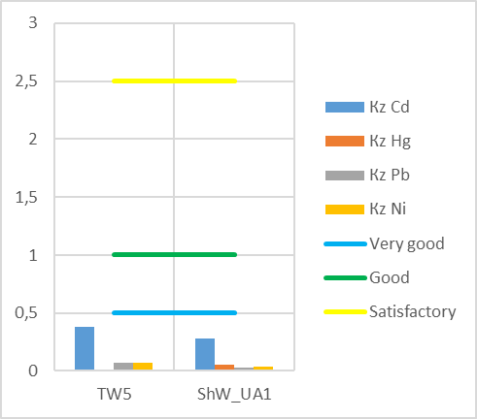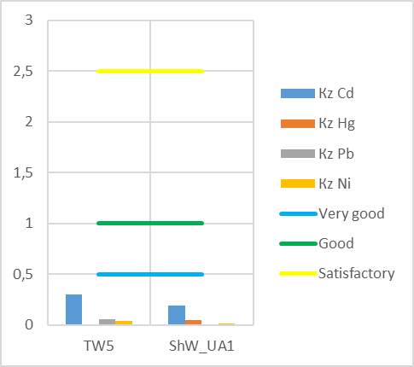
a) b) c)
а – Кz TM surface and bottom layer of water
b – Кz individual TM surface layer of water
c – Кz individual TM bottom layer of water
Figure 3.2 - Kz TM of sea water by district in 2021

Figure 3.3 shows the contributions of individual metals to the pollution of the TM group.

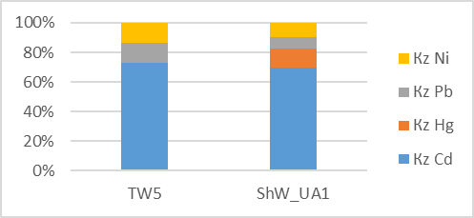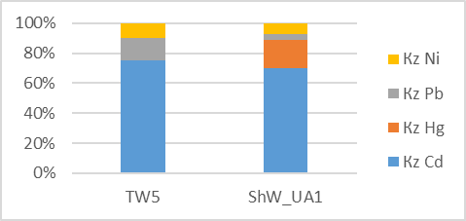
а) b)
а – surface and bottom layer of water
b – bottom layer of water
Figure 3.3 – Contribution of Kz of individual metals to seawater pollution by region in 2021

The greatest contribution to the pollution of the TM group in all the studied areas is from cadmium concentrations, in the TW5 area in the second place of lead in the Danube district (ShW_UA1) mercury.

3.1.2 Ecological assessment of the state of sea water by district according to the content of organic pollutants of agricultural origin (OPAO)

Table 3.3 and Figure3.4 show Kz for individual OPAOs and the average Kz for OPAOs in the surface and bottom layer of water according to 2021 data by district. The environmental assessment was carried out in accordance with EU directive 2013/39/EU (MAC-EQS).

Table 3.3 Kz OPAOs of the surface and bottom layer of sea water in 2021
Area | layer | Кz ОPAO | Кz DDT¹ | Кz ∑DDT² |  | Кz ∑HCH³ | Кz HCB⁴ | Кz heptachlor | Кz ∑ cyclodiene⁵ | Кz Atrazine | Кz Dyrsban
TW5 | surface | 2,28 | 0,30 | 0,20 |  | 0,07 | 0,01 | 17,22 | 0,46 | 0,00 | 0,01
ShW_UA1 | surface | 9,32 | 0,59 | 0,51 |  | 0,15 | 0,02 | 72,44 | 0,79 | 0,00 | 0,02
TW5 | bottom | 3,85 | 0,24 | 0,16 |  | 0,31 | 0,01 | 29,72 | 0,35 | 0,00 | 0,00
ShW_UA1 | bottom | 2,89 | 0,32 | 0,20 |  | 0,29 | 0,01 | 21,64 | 0,54 | 0,01 | 0,15
1 – p,p-dichlorodiphenyltrichloroethane  2 – sum DDT and its metabolites  3 – the sum of lindane and its isomers |  |  |  |  | 4 – hexachlorobenzene  5 – sum of aldrin, dieldrin and endrin

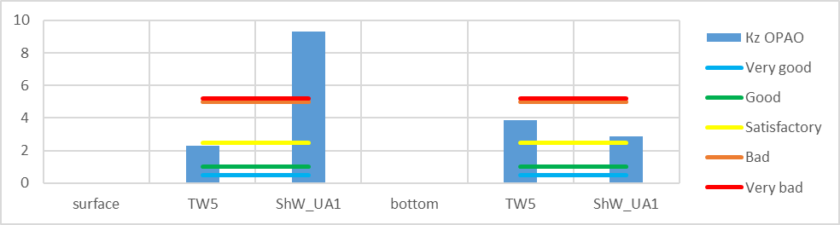
a)
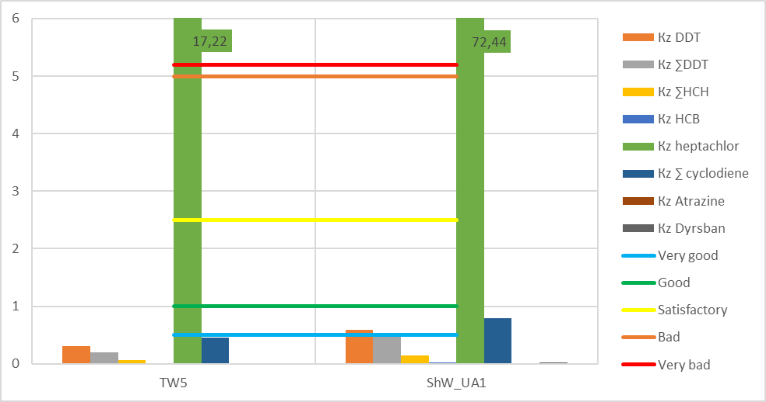
b)
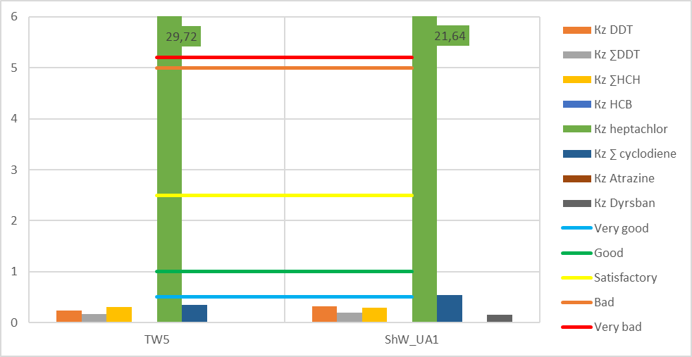
c)
а – Кz ОPAOs surface and bottom layer of water
b – Кz individual ОPAOs surface layer of water
c – Кz individual ОPAOs bottom layer of water
Figure 3.4 - Kz OPAOs of sea water by district in 2021.

As can be seen from Table 3.3 and Figure3.4, in 2021, Kz OPAOs in the districts varies from satisfactory to very bad ecological condition. The main pollutant among the OPAOs group is heptachlor, Kz of heptachlor in the surface and bottom layer of water in all regions corresponds to a very bad ecological condition.

Figure 3.5 shows the contributions of individual OPAOs to the pollution of the OPAOs group.

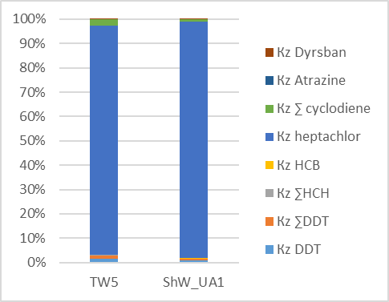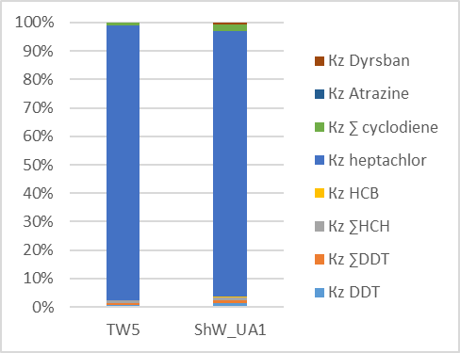
а) b)
а – surface and bottom layer of water
b – bottom layer of water
Figure 3.5 - The contribution of Kz of individual OPAOs to sea water pollution by district in 2021

It can be seen from Figure 3.5 that the largest contribution to pollution by the OPAOs group is made by the concentration of heptachlor in all regions in the surface and bottom layers of water.

3.1.3 Ecological assessment of the state of sea water by district according to the content of organic pollutants of industrial origin (OPIO)

Table 3.4 and Figure 3.6 show the Kz of the OPIOs group and the Kz of individual OPIOs of the surface and bottom layer of sea water by region in 2021.
Since the EU directive 2013/39 does not have limits on the concentrations of non-dioxin PCBs, the maximum permissible concentrations for polychlorinated biphenyls (PCBs) are taken from the recommendations of the EAC, OSPAR SIME 2008.
Kz of polyaromatic hydrocarbons (PAHs) was calculated relative to MAC-EQS EU 2013/39.

Table 3.4 Kz OPIOs of the surface and bottom layer of sea water in 2021.
Area | layer | Кz ОPIO | Кz PCB 101 | Кz PCB 118 | Кz PCB 153 | Кz PCB 138 | Кz PCB 180 | Кz naphthalene | Кz anthracene | Кz fluoranthene | Кz benzo(b)fluoranthene | Кz benzo(k)fluoranthene | Кz benzo(a)pyrene | Kz benzo(g,h,i)perylene
TW5 | surface | 9,04 | 85,3 | 16,1 | 6,75 | 0,14 | 0,00 | 0,00 | 0,07 | 0,01 | 0,01 | 0,00 | 0,00 | 0,11
ShW_UA1 | surface | 11,3 | 82,0 | 27,6 | 24,9 | 0,24 | 0,44 | 0,00 | 0,07 | 0,01 | 0,01 | 0,00 | 0,00 | 0,15
TW5 | bottom | 6,49 | 59,0 | 12,2 | 5,75 | 0,10 | 0,38 | 0,00 | 0,09 | 0,01 | 0,02 | 0,01 | 0,01 | 0,30
ShW_UA1 | bottom | 12,5 | 119 | 18,3 | 11,3 | 0,21 | 0,00 | 0,00 | 0,07 | 0,04 | 0,03 | 0,02 | 0,01 | 0,53

As can be seen from Table 3.4 and Figure 3.6, Kz OPIOs in 2021 in all regions in the bottom and surface layer of water correspond to a very bad ecological condition. In all districts, the concentration of individual PCBs 101, 118, 153, and their Kz corresponded to a very bad ecological state, had the greatest impact on the ecological state.

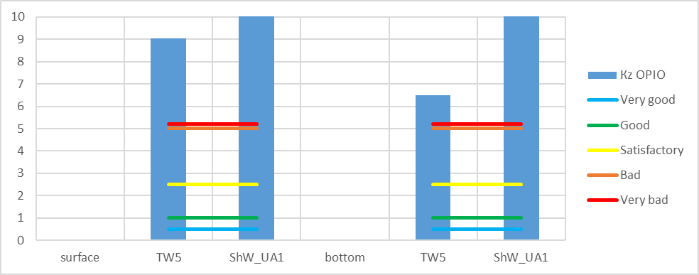
a)
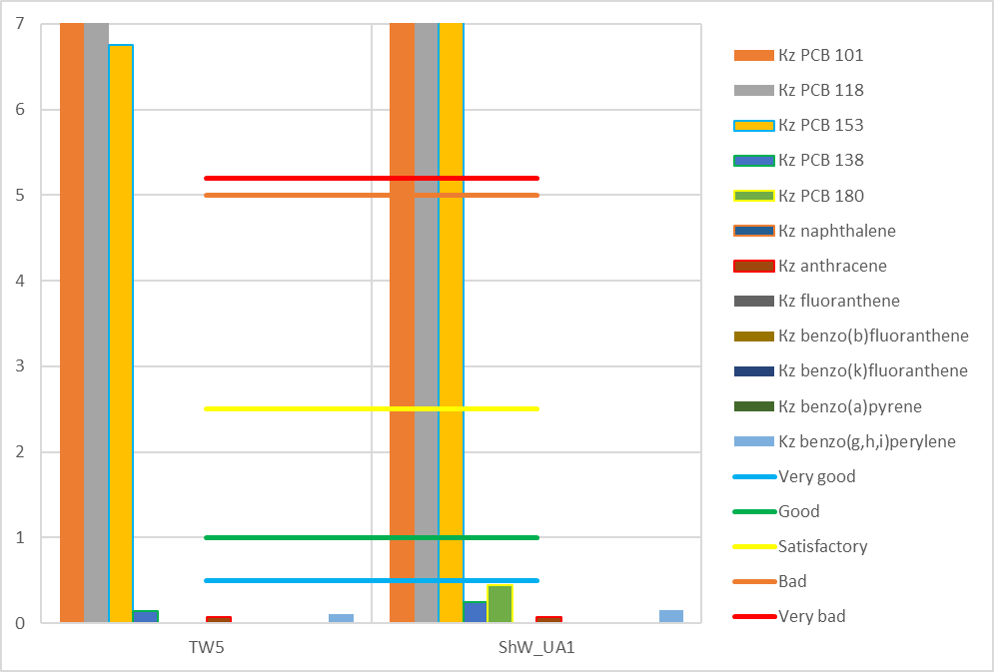
b)
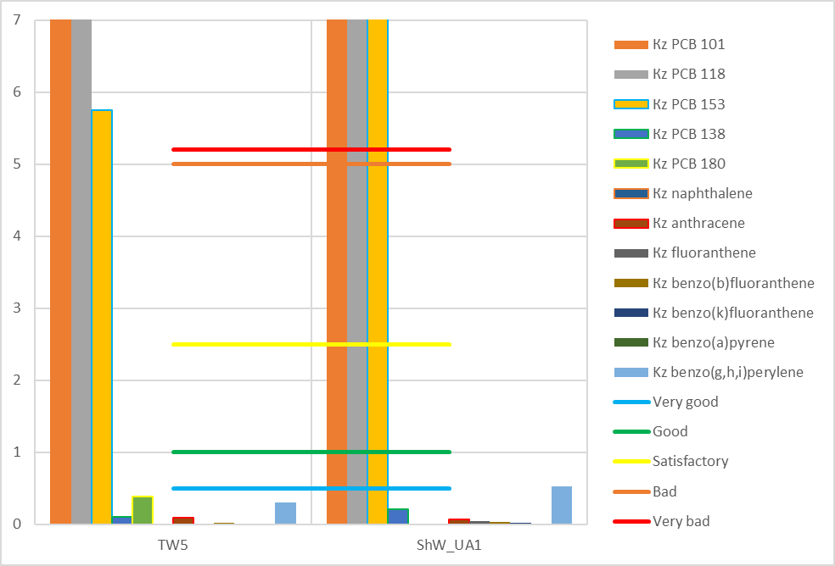
c)
а – Кz ОPIOs surface and bottom layer of water
b – Кz individual ОPIOs surface layer of water
c – Кz individual ОPIOs bottom layer of water
Figure 3.6 - Kz OPIOs of sea water by regions in 2021

Table 3.5 and Figure 3.7 show the average values of the sum of PAHs (∑ PAHs), benzo(a)perene equivalent (B(a)Peq) and the sum of carcinogenic PAHs (∑ carc PAHs) in the surface and bottom layer of sea water by region in 2021 year. Indicators ∑ PAHs are at a low level.

Table 3.5 Sum of PAHs, benzo(a)perene equivalent and sum of carcinogenic PAHs of the surface and bottom layer of sea water in 2021.
Area | Ʃ PAHs | B(a)Peq | Σ carc PAHs | Ʃ ПАВ | B(a)Peq | Σ carc PAHs
Area | surface layer of water |  |  | bottom layer of water
TW5 | 40,11 | 0,40 | 0,41 | 47,27 | 0,83 | 1,28
ShW_UA1 | 37,73 | 0,38 | 0,39 | 60,39 | 1,41 | 1,94

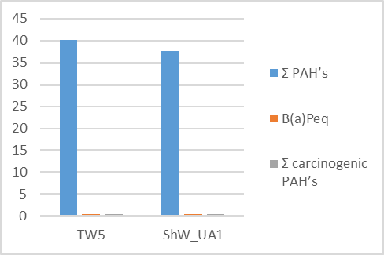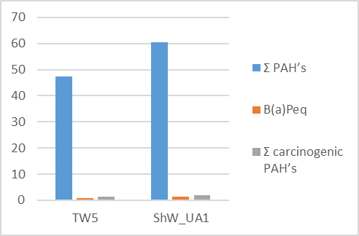
а) b)
а – surface layer of water
b – bottom layer of water
Figure 3.7 – Average values of ∑ PAHs, B(a)Peq and ∑ carc PAHs in surface and
bottom layer of sea water by district in 2021

PAHs in seawater in these areas is higher compared to the baseline and 2019 estimates, but significantly reduced compared to 2020.
Figure 3.8 shows that in 2021, PCB 101,118,153 made the biggest contribution to seawater pollution by the OPIOs group.

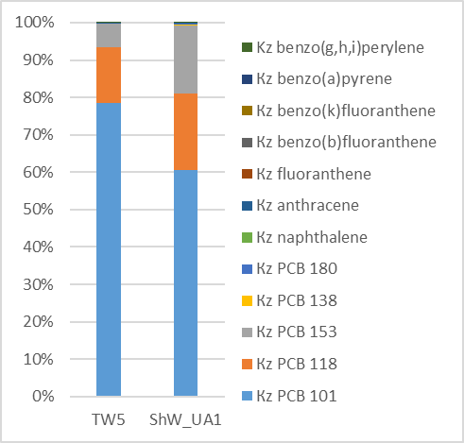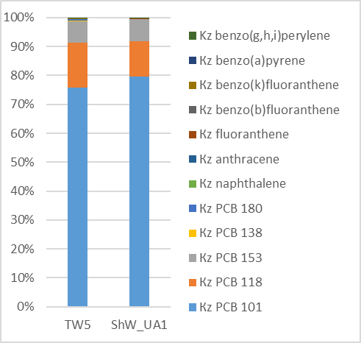
a) b)
а – surface layer of water
b – bottom layer of water

Figure 3.8 – The contribution of individual OPIOs to seawater pollution by district in 2021

3.1.4 Environmetal state of bottom sediments by district by content of pollution

The condition of the bottom sediments was assessed by such pollutants as: toxic metals (TM), organochlorine pesticides (OCPs) and polyaromatic hydrocarbons (PAHs).

Scale for assessing the ecological condition of bottom sediments using Kz:
for ТМ | for organic compounds
Very good when K is less than 0,5 | Very good when K is less than 0,2
Good when K from 0,5 to 1,0 | Good when K from 0,2 до 1,0
Satisfactory when K from 1,0 to 1,25 | Satisfactory when K from 1,0 to 5,0
Bad when K from 1,25 to 2,5 | Bad when Kz from 5,0 to 25;
Very bad when K is more than 2,5 | Very bad when Kz is more than 25

3.1.5 Toxic metals in bottom sediments

Table 3.6 and Figure 3.9 show Kz TM and Kz individual TM in bottom sediments by district in 2021. For toxic metals, Kz was calculated in relation to environmental regulations (ER).

Table 3.6 Kz TM in bottom sediments by district in 2021
Район | Кz ТМ | Кz Cd | Кz Cr | Кz Cu | Кz As | Кz Hg | Кz Pb | Кz Zn | Кz Ni | Кz Co
TW5 | 0,58 | 0,37 | 0,83 | 0,88 | 0,30 | 0,21 | 0,27 | 0,64 | 1,28 | 0,46
ShW_UA1 | 0,42 | 0,28 | 0,59 | 0,58 | 0,22 | 0,19 | 0,26 | 0,54 | 0,82 | 0,27

As can be seen from Table 3.6 and Figure 3.9, Kz TM in all districts correspond to good and very good ecological status. But nickel concentrations in the TW5 area were elevated and corresponded to poor environmental conditions.

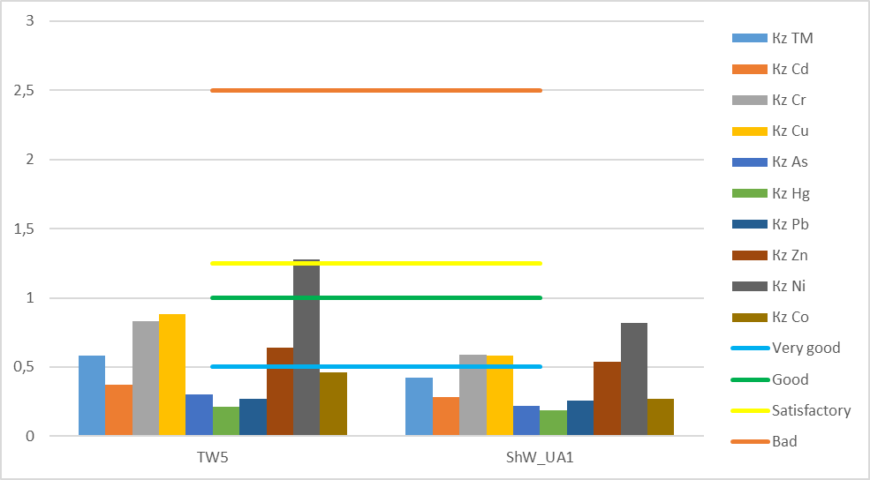

Figure 3.9 – Kz TM of bottom sediments by district in 2021

Figure 3.10 shows the contributions of individual TMs to the contamination of bottom sediments by the TM group. It can be seen that the metals are distributed in the same way in the studied areas. Ni, Zn, Cu, Cr and Cd are present in higher concentrations.
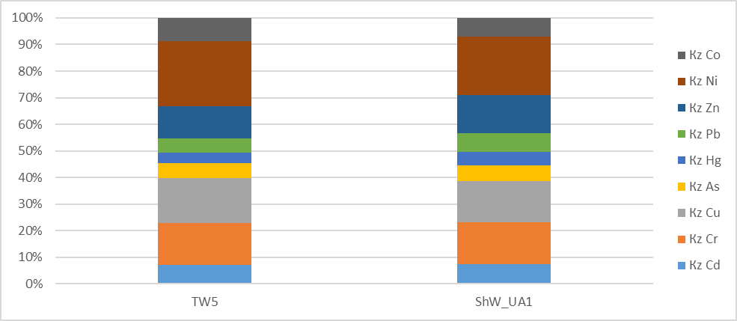

Figure 3.10 - Contribution of Kz of individual TM to the pollution of bottom sediments by district in 2021.

3.1.6 Organic pollutants of agricultural origin in bottom sediments.

Table 3.7 shows Kz OPAOs in bottom sediments by district in 2021. For OPAOs, Kz was calculated in relation to limit concentrations with ER.

Table 3.7 - Kz of OPAOs in bottom sediments by district in 2021
Area | Кz ОPAO | Кz ∑DDT | Кz α-HCH | Кz β-HCH | Кz lindane | Кz ∑HCH | Кz HCB | Кz heptachlor | Кz aldrine | Кz dieldrine
TW5 | 22,91 | 21,56 | 1,07 | 105,9 | 47,95 | 22,2 | 1,11 | 1,64 | 1,57 | 3,20
ShW_UA1 | 28,91 | 37,13 | 1,79 | 22,9 | 177,4 | 7,25 | 3,01 | 3,36 | 2,95 | 4,47

As can be seen from Table 3.7 and Figure 3.11:
- in the ТW5 water body, the Kz of OPAOs corresponds to a poor ecological status, the Kz of ∑DDT and ∑HCH corresponds to a poor ecological status, and the Kz of β-HCH and lindane corresponds to a very bad ecological status, the Kz of α-HCH, hexachlorobenzene, heptachlor, aldrin, and dieldrin corresponds to a satisfactory ecological status state;
- in the area of ShW_UA1, Kz OPAOs corresponds to a very bad ecological condition, a high level of contamination of Kz ∑DDT and Kz lindane corresponds to a very bad ecological condition, Kz β-HCH and ∑HCH correspond to a bad ecological condition, Kz α-HCH, hexachlorobenzene, heptachlor, aldrin was recorded and dieldrin corresponds to a satisfactory ecological condition.

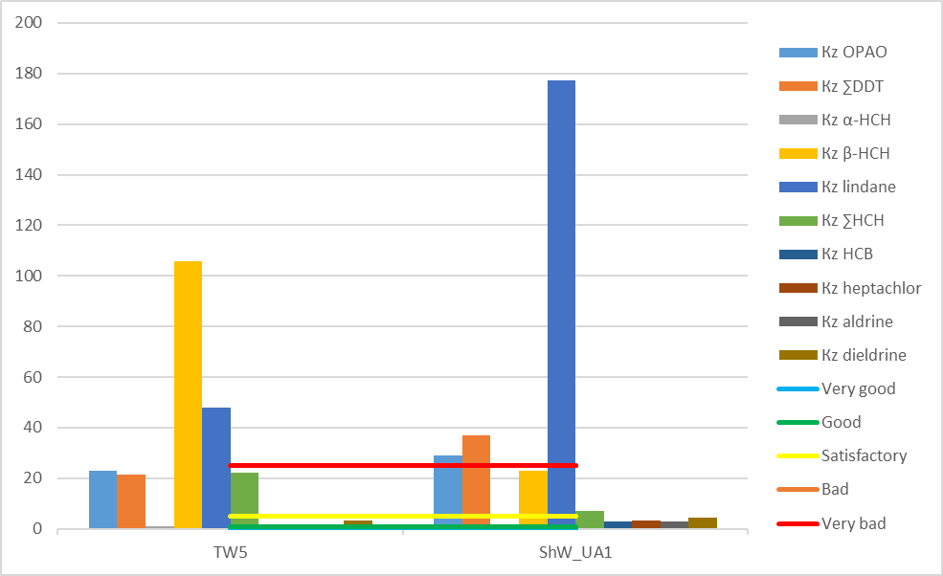

Figure 3.11 - Kz OPAOs of bottom sediments by district in 2021

Figure 3.12 shows the contributions of individual OPAOs to the pollution of bottom sediments by the OPAOs group.

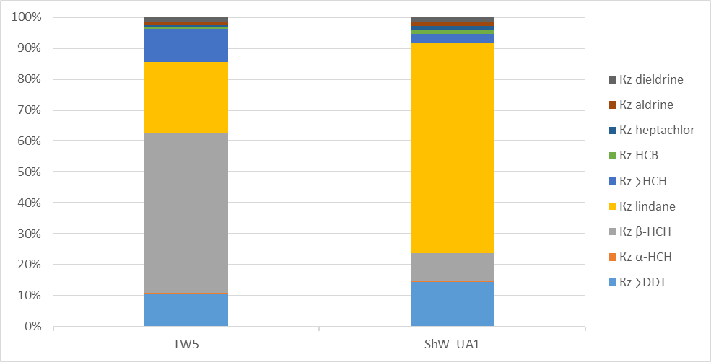

Figure 3.12 - The contribution of Kz of individual OPAOs to the pollution of bottom sediments by district in 2021.

As follows from the figure in the TW5 area the main polluting compounds are hexachlorohexane isomers with a preference for β-HCH, in the ShW_UA1 area the main contribution to pollution is made by hexachlorohexane isomers with a preference for lindane.

3.1.7 Organic pollutants of industrial origin in bottom sediments

Table 3.8 and Figure 3.13 show the Kz OPIOs in bottom sediments by district in 2021. Kz of individual OPIOs was calculated in relation to the limit concentrations according to ER.

Table 3.8 Kz of the OPIOs group and individual OPIOs in bottom sediments by district in 2021.
Area | Кz ОPIO | Кz Ar-1254 | Кz Ar-1260 | Кz naphthalene | Кz phenanthrene | Кz anthracene | Кz fluoranthene | Кz benzo(a)anthracene | Кz Chrysen | Кz benzo(k)fluoranthene | Кz benzo(a)pyrene | Кz indeno(1,2,3cd)pyrene | Кz benzo(g,h,i)perylene
TW5 | 1,66 | 0,52 | 0,03 | 0,25 | 3,48 | 0,37 | 11,9 | 0,00 | 0,15 | 0,70 | 0,77 | 0,58 | 1,14
ShW_UA1 | 0,88 | 0,62 | 0,15 | 0,28 | 1,98 | 0,33 | 4,44 | 0,19 | 0,22 | 0,23 | 0,68 | 0,55 | 0,85

As can be seen from Table 3.8 and Figure 3.13:
- in the area of TW5 Kz OPIOs corresponds to a satisfactory ecological condition, this was affected by the concentrations of phenanthrene (Kz - satisfactory), fluoranthene (Kz - bad), benzo(g,h,i)perylene (Kz - satisfactory)
- in the area of ShW_UA1 Kz OPIOs corresponds to a good ecological condition, but increased concentrations of phenanthrene (Kz - satisfactory), fluoranthene (Kz - satisfactory) were recorded.

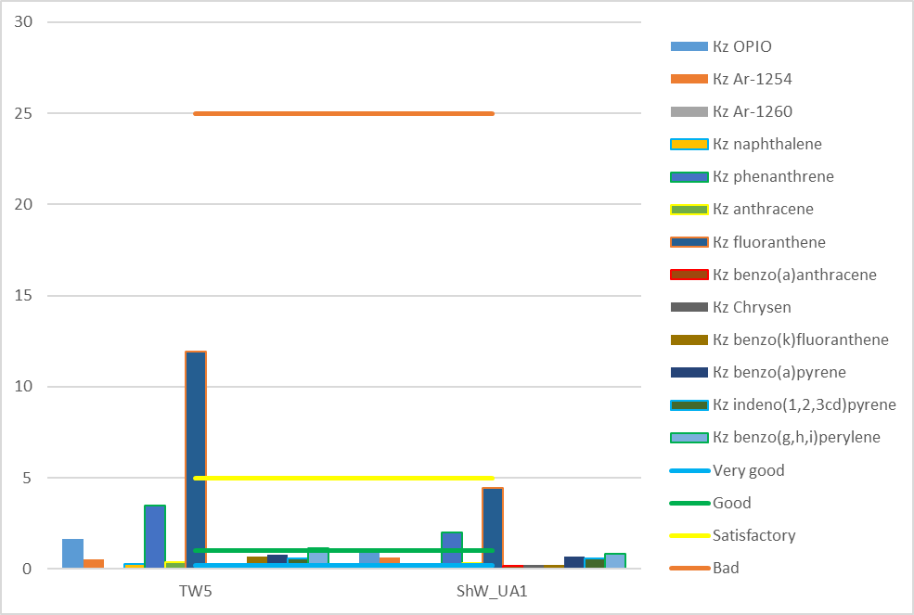

Figure 3.13 - Kz OPIOs of bottom sediments by district in 2021
Figure 3.14 shows the contributions of individual OPIOs to the pollution of bottom sediments by the group of OPIOs, in the area of TW5 and ShW_UA1 in 2021, the main polluting compound are fluoranthene.

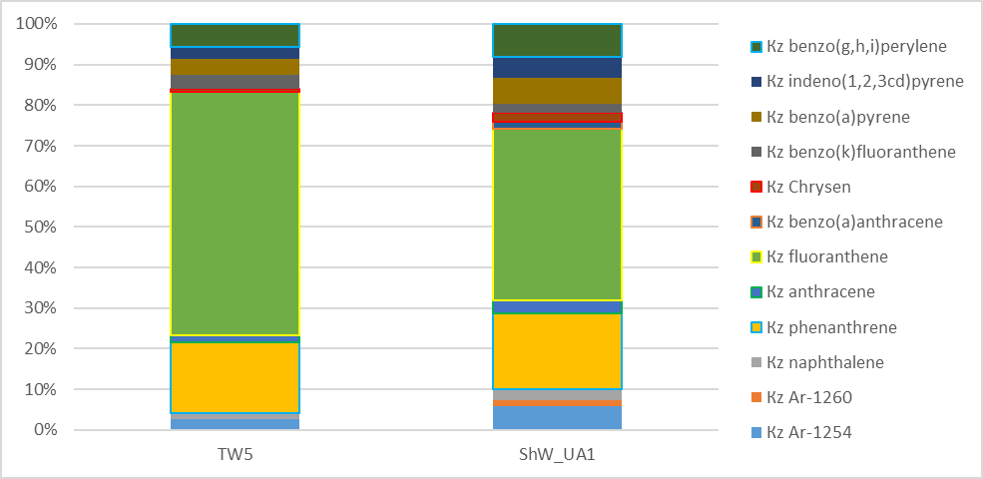

Figure 3.14 - The contribution of Kz of individual OPIOs to the pollution of bottom sediments by district in 2021.

Table 3.9 shows the average values of ∑ PAHs, B(a)Peq, Sums of carcinogenic PAHs [13] and geochemical markers calculated from the average values of PAHs concentrations for bottom sediments by district in 2021. Sum of carcinogenic PAHs exceeds B(a)Peq in the studied areas, which characterizes the presence of compounds that do not have a high toxic effect on biological objects, but can accumulate in them and cause irreversible changes in genetics.

Table 3.9 Average concentrations of surfactants and geochemical markers of bottom sediments in 2021.
Area | ∑ PAHs | B(a)Peq | ∑ carc PAHs | Ph/An | (Py+Flu)/  (Chr+Ph) | An/178 | Flu/Py | Flu/  Flu+Py | BaA/228
TW5 | 572,57 | 63,71 | 221,07 | 8,43 | 1,41 | 0,11 | 3,89 | 0,80 | 0
ShW_UA1 | 412,75 | 55,24 | 134,77 | 5,36 | 1,87 | 0,16 | 0,62 | 0,38 | 0,46

Using geochemical markers, such as the ratio of phenanthrene to anthracene (Ph/An), the ratio of the sum of pyrene and fluoranthene to the sum of chrysene and phenanthrene ((Py+Flu)/(Chr+Ph)), the ratio of anthracene to the sum of compounds with a molecular weight of 178 (An/178), the ratio of fluoranthene to pyrene (Flu/Py), the ratio of fluoranthene to the sum of fluoranthene and pyrene (Flu/(Flu+Py)), the ratio of benzo(a)anthracene to the sum of compounds with a molecular weight of 228 (BaA/228 ) it is possible to assess the nature of pollution and the sources of these pollutions [14].
Table 3.10 provides an assessment of the nature of PAHs pollution and probable sources of pollution by geochemical markers by region in 2021, calculations were made based on average concentrations of PAHs. In the bottom sediments of the studied areas, pollution originating from the burning of raw materials and fuel prevails.

Table 3.10 Assessment of the nature of PAHs pollution and probable sources of pollution in 2021.
Area | Ph/An | (Py+Flu)/  (Chr+Ph) | An/178 | Flu/Py | Flu/Flu+Py | BaA/228 | Classification of samples by contamination
TW5 | pyrogenic PAHs | pyrogenic PAHs | PAHs from diesel oil, shale oil, coal and some crude oil samples | petrogenic PAHs | pyrogenic PAHs (burning kerosene and grass, most coal and wood; creosote) | petrogenic PAHs | very polluted
ShW_UA1 | pyrogenic PAHs | pyrogenic PAHs | PAHs from diesel oil, shale oil, coal and some crude oil samples | pyrogenic PAHs, burning wood | petrogenic PAHs (most petroleum products and their combustion products) | pyrogenic PAHs | polluted
Bottom deposits can be classified into 3 categories depending on the total content of PAHs, recommendations [15]:
• <250 μg/kg – slightly polluted.
• 250 - 500 μg/kg - polluted.
• >500 μg/kg – very polluted.
According to the specified classification, the bottom sediments of the water body TW5 are characterized as highly polluted, the bottom sediments in the ShW_UA1 area are characterized as polluted, see table 3.11.

3.1.8 Сonclusions (comparison of the environmental state of the researched regions of nwbs in 2021 with the base assessment and the assessment in 2019 and 2020)

Water body TW5 overall assessment in 2021 is very bad.
Water body ShW_UA1 overall assessment in 2021 is very bad.
Table 3.11 shows the ecological assessment of the regions of the NWBS by year.
Table 3.11 – Ecological assessment of regions of the NWBS by years.
Area | Basic |  | 2019 year |  | 2020 year |  | 2021 year
Area | Environmental assessment | Compounds or analyzed group of compounds whose Kz exceeds 1.0 | Environmental assessment | Compounds or analyzed group of compounds whose Kz exceeds 1.0 | Environmental assessment | Compounds or analyzed group of compounds whose Kz exceeds 1.0 | Environmental assessment | Compounds or analyzed group of compounds whose Kz exceeds 1.0
CW1 (Island Zmeinyi)
Overall assessment | Bad |  | Very bad |  | Very bad |  | -
surface layer of water | Satisfactory | heptachlor, Ar-1260 | Very good | benzo(g,h,i) perylene | Very bad | DDT, ∑DDT, heptachlor, PCB101, PCB118, PCB138 | - | -
bottom layer of water | Bad |  | Very bad | ДДТ, heptachlor, benzo(g,h,i) perylene | - | - | - | -
bottom sediments | Satisfactory | ∑DDT, β-HCH, lindane, Ar-1254, fluoranthene | Bad | ∑ DDT, β-HCH, lindane, ∑ HCH, Ar-1254, phenanthrene, fluoranthene | Very good | OCPs, PCBs and PAHs were not investigated | - | -

Continuation of table 5.1
Area | Basic |  | 2019 year |  | 2020 year |  | 2021 year
Area | Environmental assessment | Compounds or analyzed group of compounds whose Kz exceeds 1.0 | Environmental assessment | Compounds or analyzed group of compounds whose Kz exceeds 1.0 | Environmental assessment | Compounds or analyzed group of compounds whose Kz exceeds 1.0 | Environmental assessment | Compounds or analyzed group of compounds whose Kz exceeds 1.0
ТW5 (Danube delta)
Overall assessment | Satisfactory |  | Very bad |  | Very bad |  | Very bad
surface layer of water | Good | heptachlor | Very bad | heptachlor, benzo(g,h,i) perylene | Very bad | mercury, DDT, heptachlor, ∑cyclodiene, PCB101, PCB118, PCB 138 | Very bad | heptachlor, PCB101, PCB118, PCB153
bottom layer of water | Very good |  | Very bad | mercury, heptachlor, benzo(g,h,i) perylene | Very bad | mercury, heptachlor, ∑cyclodiene, PCB101, PCB118, PCB138 | Very bad | heptachlor, PCB101, PCB118, PCB153
bottom sediments | Satisfactory | ∑DDT, lindane | Satisfactory | zinc, nickel, ∑DDT, lindane, Ar-1254 | Satisfactory | ∑DDT, dieldrin, Ar-1254 | Bad | nickel, ∑DDT, α-HCH, β-HCH, lindane, ∑HCH, hexachlorobenzene, heptachlor, aldrin, dieldrin, phenanthrene, fluoranthene, benzo(g,h,i) perylene

End of table 5.1
Area | Basic |  | 2019 year |  | 2020 year |  | 2021 year
Area | Environmental assessment | Compounds or analyzed group of compounds whose Kz exceeds 1.0 | Environmental assessment | Compounds or analyzed group of compounds whose Kz exceeds 1.0 | Environmental assessment | Compounds or analyzed group of compounds whose Kz exceeds 1.0 | Environmental assessment | Compounds or analyzed group of compounds whose Kz exceeds 1.0
ShW_UA1 (Danube district)
Overall assessment | Satisfactory |  | Very bad |  | Very bad |  | Very bad
surface layer of water | Satisfactory | heptachlor | Very bad | heptachlor | Very bad | mercury, DDT, ∑DDT, ∑HCH, heptachlor, ∑cyclodienes, PCB101, PCB118, PCB153, PCB138, PCB180 | Very bad | heptachlor, PCB101, PCB118, PCB153
bottom layer of water | Satisfactory |  | Very bad | heptachlor | Very bad | mercury, DDT, ∑DDT, ∑HCH, heptachlor, ∑cyclodienes, PCB101, PCB118, PCB153, PCB138 | Very bad | heptachlor, PCB101, PCB118, PCB153
bottom sediments | Good | ∑DDT, lindane, fluoranthene | Satisfactory | Nikel, ∑DDT, lindane, Ar-1254 | Bad | ∑DDT, lindane, dieldrin, Ar-1254 | Very bad | ∑DDT, α-HCH, β-HCH, lindane, ∑HCH, hexachlorobenzene, heptachlor, aldrin, dieldrin, phenanthrene, fluoranthene

LIST OF REFERENCE SOURCES

1. RD 52.10.243-92. Guide to chemical analysis of sea waters. St. Petersburg: Hydrometeoizdat, 1993. 263 p.
2. MVV No. 13/09-09 Sea waters. The method of measuring the mass concentration of cadmium, cobalt, nickel, copper, arsenic, lead and zinc by the method of atomic absorption flame and non-flame spectrophotometry. Odesa: UkrNTSEM, 2009. 15 p.
3. MVV No. 12/09-09 Sea waters. The technique of measuring the mass concentration of iron, manganese and chromium by the method of non-flame atomic absorption spectrophotometry. Odesa: UkrNTSEM, 2009. 15 p.
4. MVV No. 11/09-09 Sea waters. The technique of measuring the mass concentration of mercury by the method of non-flame atomic absorption spectrophotometry (chlorine vapor method). Odesa: UkrNTSEM, 2009. 14 p.
5. MVV No. 18/09-09 Bottom sediments. The method of measuring the mass fraction of aluminum, cadmium, cobalt, manganese, copper, arsenic, nickel, lead, chromium, iron and zinc by atomic absorption spectrophotometry. Odesa: UkrNTSEM, 2009. 14 p.
6. MMV No. 10/09-09 Sea waters. Methodology for measuring the mass concentration of organochlorine pesticides (OCPs) and polychlorinated biphenyls (PCBs) by capillary gas-liquid chromatography. Odesa: UkrNTSEM, 2009. 15 p.
7. EPA METHOD 8270C SEMIVOLATILE ORGANIC COMPOUNDS BY GAS CHROMATOGRAPHY/MASS SPECTROMETRY (GC/MS). USA, 1986
8. MMV No. 19/09-09 Bottom deposits. Methodology for measuring the mass concentration of organochlorine pesticides (OCPs) and polychlorinated biphenyls (PCBs) by gas-liquid chromatography. Odesa: UkrNTSEM, 2009. 15 p.
9. EPA METHOD 8275A SEMIVOLATILE ORGANIC COMPOUNDS (PAHs AND PCBs) IN SOILS/SLUDGES AND SOLID WASTES USING THERMAL EXTRACTION/GAS CHROMATOGRAPHY/MASS SPECTROMETRY (TE/GC/MS). USA, 1996
10. Environmental reguleytions norms of the marine environment. Odesa: UkrNTSEM, 2008. 15 p.
11. Hydrological and hydrochemical indicators of the state of the northwestern shelf of the Black Sea: reference guide [Text] / I.H. Orlova, M.Yu. Pavlenko, V.V. Ukrainian [and others]; answer ed. ID. Loyeva. - K.: KNT, 2008. - 616 p.
12. Iarochevitch Alexei Proposal. For Delineation of Transitional and Coastal Water Bodies in the Ukrainian and Georgian part of the Black Sea and related maps (Draft). [Text] / Developed by: Alexei Iarochevitch/ This report has been produced with the assistance of the European Union. May 2017. - 28 p.
13. Larsen J.C., Larsen P.B. Chemical carcinogens. In: Hester R.E., Harrison R.M., editors. Air Pollution and Health. The Royal Society of Chemistry; Cambridge, UK: 1998. pp. 33–56.
14. Haustov A.P. Polycyclic aromatic hydrocarbons as geochemical markers of oil pollution of the environment / A.P. Haustov, M.M. Redina // Ecology. -2014. - number 2. - P. 92 - 96
15. Traven L. CYP1A Induction potential and the concentration of pollutants in marine sediment simples – In vitro evaluation using the PLH - 1 fish hepatoma cell line / L. Traven, R. Zaja, J. Loncar // Toxicology in vitro. – 2008. – T. 22 – N 6. – P. 1648 – 1656

4 ASSESSMENTS of biodiversity and coastal communities of the North-West Black Sea region

Introduction
Biodiversity is one of the most important environmental characteristics of marine ecosystems. The biological organisms are objective indicators of the environmental state. There is a particularly large variety of hydrobionts in the coastal waters of aquatic ecosystems, their community structure reflects their environmental status. Biocenoses play an important role in key ecosystem processes (primary production, food webs, recycling, etc.). But they are exposed to anthropogenic impact, which poses a risk to their functionality. Marine Framework (MSFD, Directive 2008/56/ EC) requires EU Member States to achieve good environmental status (GES). To achieve GES, it is necessary to constantly monitor the status of marine ecosystems.
Hydrobiological studies of the north-western part of the Black Sea (NWBS) were conducted to assess the quality of marine ecosystems by biological methods and to assess the state of pelagic and benthic aquatic communities in different parts Ukraine marine territories.

Phytoplankton.
During 2021, 169 species and varieties of microalgae belonging to 11 systematic divisions were noted in the phytoplankton of the coastal water bodies of the Odesa region: Bacillariophyta (47%), Dinophyta (18%), Chlorophyta (12%), Cyanophyta (11%), Prymnesiophyceae (3%), Chrysophyceae (3%), Cryptophyceae (1 %), Euglenophyta (1 %), Dictyochophyceae (1 %), Choanoflagellatea (1 %) and Flagellata (2 %) (Figure 4.1).

Figure 4.1 – Taxonomic diversity of microalgae at stations in the Odesa region in 2021

Shannon's species diversity index in microalgae samples during the study period varied in a wide range from 0.82 to 2.88 bits·ind.⁻¹. The annual changes in the index can be seen in Figure 4.2.

Figure 4,2 – Average monthly values of Shannon index in the Odesa region in 2021
During 2021, the coastal phytoplankton was formed mainly by the marine complex of species. The average value of the abundance was 243 thousand cells ·l⁻¹, which is slightly more than in 2020; biomass - 230 mg·m⁻³, which is slightly lower than in previous years (Figure 4.3).

Figure 4.3 – Quantitative indicators of phytoplankton in the Odesa region in 2021,
а) abundance; b) biomass

In 2021, quantitative indicators of phytoplankton were quite high. In the summer, the number varied from 69 to 751 thousand cell∙l⁻¹, and in autumn from 629 to 1629 thousand cells∙l⁻¹. Biomass ranged from 235 to 3516 mg∙m-3 in summer and from 242 to 2648 mg∙m⁻³ in autumn. In 2021, the so-called "green tide" was observed in the coastal sea masses. The main causative species was the cyanobacterium Aphanizomenon flosaquae Ralfs ex Bornet&Flahault (biomass was 753,04 mg∙m⁻³). It is a freshwater species that forms macroscopic tufted colonies, included in the list of toxic species of UNESCO. It produces neurotoxins (toxoid and paralytic toxins of molluscs PSP). In the Odesa region, this species developed massively in 2010 and 2015. Water quality assessment is based on quantitative and qualitative indicators of phytoplankton, therefore it undergoes significant seasonal and spatial fluctuations.
Water quality was assessed according to the scale developed by UkrSCES as part of the state research work "Basic assessment and determination of good ecological status (GES) of biocenoses and biodiversity of the Black Sea within the exclusive marine economic zone of Ukraine", according to which the main parameter for assessing water quality phytoplankton indicators are its biomass. The BAC: DIN (spring) МЕС% (summer) and Menkhinik indices were also used for the assessment, but it should be taken into account that these indices were developed for the Bulgarian coast and are in the process of being adapted to Ukrainian waters.
In the summer of 2021, according to phytoplankton biomass indicators, the water quality at most stations could be assessed as "Excellent", with the exception of the Luzanivka station, where a water bloom was observed. In the autumn period, water quality corresponded to the "Excellent" category only at half of the stations. At the Odesa, Arkadia and Zatoka stations, the water quality was rated as "Moderate", and at the Luzanivka and Yuzhnyi stations as "Poor". Regarding the Menkhinik index, according to this indicator, the water quality was rated as "Good" only in summer at the Cape Small Fontaine station (CW5).
At the beach stations named after sanatoriums of Chkalov and Arkady (CW5) according to the Menkhinik index, it was rated as "Average", and at other stations as "Poor" and "Very bad". In the autumn period, at no station did the water quality reach the "Average" level according to the Menkhinik index. Thus, to generalize, in the summer period Luzanivka, Odesa port and Zatoka stations were outside the GES category, in the autumn period, on the contrary, the water quality corresponded to the GES only at two stations - Dolphin beach and Dacha Kovalevsky.

Zooplankton.
During 2021, 43 taxa of species rank and above of marine, brackish and freshwater zooplankton complexes were identified in all studied water areas. This is significantly less than in previous years (61 and 63 taxa in 2019 and 2020, respectively). Copepoda (15 taxa) formed the core of diversity, meroplankton was diverse - 5 taxa, Cladocera were represented by 3 taxa, rotifers - 4 taxa, protozoa - 3 taxa, comb jellies and jellyfish together - 4 taxa. Other organisms were represented by 9 taxa. Zooplankton was numerous only in the warm part of the year when the water temperature was above +8 °C. During the year, two maxima of mesozooplankton development were observed - spring and autumn. The annual average number and biomass were 2684 ind∙m⁻³ and 13,10 mg∙m⁻³ (Fig. 4.4).

А

B
Figure 4.4 – Average abundance (A) and biomass (B) of mesozooplankton
in the Odesa region at 2021

Among the quantitative indicators of mesozooplankton, the worst levels were demonstrated by the indicators of the share of copepods and diversity according to the Shannon index. The highest levels were demonstrated by the percentage of gelatinous animals and total biomass. The assessment of the quality of the environment by the quantitative indicators of mesozooplankton was carried out according to the Integral Zooplankton Index (IZI) (Alexandrov, 2016), which combines the assessment of all zooplankton metrics. During the study period, the index varied from 0.51 in July to 0.92 in September and averaged 0.83 in 2021. According to the IZI indicators, most of the year can be characterized as corresponding to the GES. The seasonal course of the index and the assessment of the state of the water area can be seen in (Figure 4.5).

Figure 4.5 – Assessment of ecological status for the mesozooplankton indicators
in the Odesa region in 2021.

Macrozoobenthos
The calculation of AMBI and m-AMBI was carried out using free software available at www.azti.es, structural indices and ANOVA were calculated with PAST 4 (available at http://folk.uio.no/ohammer/past/).

During the study period, 23 taxa of species rank or higher were noted. Molluscs, crustaceans and polychaete worms have the greatest diversity (Fig. 4.6). Whittaker's beta-diversity index had a low value of 3.07. The following species Alitta succinea, Capitella capitata, Lentidium mediterraneum, Mytilus galloprovincialis, Spio filicornis were the most common (Table 4.1). The abundance and biomass varied widely. The number of species (S) per station varied from 2 to 9. The abundance did not exceed 2.7 thousand ind.·m⁻², and biomass varied widely from 2 to 500 g·m⁻².

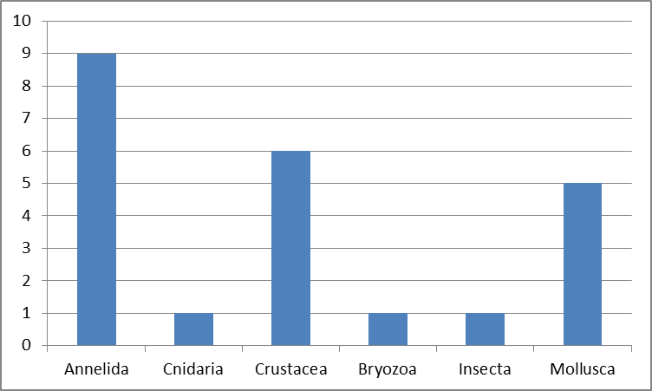

Figure 4.6. – Taxonomic composition of the macrozoobenthos of the Ukrainian sector
of the Black Sea

Table 4.1 - Taxa occurrence
Taxa | Month |  | Total
Taxa | 06/ 21 | 10 /21 | Total
Abra nitida | 10% | 0% | 5%
Actinia equina | 10% | 0% | 5%
Alitta succinea | 90% | 70% | 80%
Amphibalanus improvisus | 10% | 10% | 10%
Aonides paucibranchiata | 40% | 10% | 25%
Capitella capitata | 60% | 70% | 65%
Cerastoderma glaucum | 0% | 10% | 5%
Chamelea gallina | 30% | 40% | 35%
Chironomus salinaruis | 40% | 0% | 20%
Dexamine spinosa | 20% | 0% | 10%
Gastrosaccus sanctus | 20% | 0% | 10%
Harmothoe reticulata | 10% | 0% | 5%
Idotea balthica | 30% | 10% | 20%
Lentidium mediterraneum | 60% | 20% | 40%
Membranipora de | 10% | 10% | 10%
Microdeutopus gryllotalpa | 60% | 0% | 30%
Mysta picta | 20% | 10% | 15%
Mytilus galloprovincialis | 60% | 30% | 45%
Nephtys hombergii | 30% | 0% | 15%
Oligochaeta sp. | 20% | 10% | 15%
Palaemon elegans | 10% | 0% | 5%
Polydora limicola | 10% | 0% | 5%
Spio filicornis | 100% | 80% | 90%

There were identified six types of benthic communities with different combinations of dominant species.
Cerastoderma glaucum-Spio filicornis
D1: the group has 3 species (Cerastoderma glaucum, Capitella capitata, Spio filicornis) The number was up to 0,2 thousand. ind.·m⁻², and biomass from 19 g·m⁻², Shannon index – 3,6 bit·ind⁻¹.
D4: Cerastoderma glaucum dominated the community in terms of biomass and abundance, accounting for 99 %.
D6: the group is formed on a sand-mud substrate. The ratio of groups of species in relation to organic matter has the following character: I - 0%, II - 0%, III - 80%, IV - 0%, V - 20, AMBI - 3.6, m-AMBI – 0,35, m -AMBI (n) -0,31. Thus, the ecological status of the macrozoobenthos group can be characterized as poor.
Chamelea gallina – Polychaeta varia
D1: The grouping is characterized by great biodiversity - only 11 species - Chamelea gallina,
Lentidium mediterraneum, Spio filicornis, Alitta succinea, Aonides paucibranchiata, Chironomus salinaruis, Gastrosaccus sanctus, Idotea balthica, Capitella capitata, Oligochaeta sp., Mytilus galloprovincialis. The abundance was 2,3 thousand. ind·m⁻², and biomass up to 54 g·m⁻², Shannon index 0,86-1,84 bit·ind⁻¹.
D4: the filterers Chamelea gallina (Linnaeus, 1758) are dominant in terms of biomass in the community, the share of which was up to 85% of the biomass of the community, Polychaeta varia gave more than 50% of the number of the community.
D6: sand-shell substrate is formed. The ratio of groups of species in relation to the organic matter has the following characteristics: I – 8,15%, II – 12,82%, III – 60,40%, IV - 1%, V – 17,63, AMBI – 3,11, m-AMBI – 0,48, m -AMBI(n) -0,42 . Thus, the ecological status of the group of macrozoobenthos can be described as poor.

Lentidium mediterraneum – Polychaeta varia
D1: grouping is distinguished by low biodiversity - only 6 species - Lentidium mediterraneum, Spio filicornis, Alitta succinea, Chironomus salinaruis, Capitella capitata, Tubificoides sp, Abra nitida. The abundance was 0,6 thousand. ind.·m⁻², and biomass 10 g·m⁻², Shannon index 1,36-1,52. Thus, all three showed images were 1,5-2 times lower than last year's
D4: Lentidium mediterraneum grouping: the share of the dominant species accounts for 95% of the biomass. At the same time, a significant share of the population is up to 41%.
D6: the grouping is formed on a sand-shell substrate. The ratio of species groups in relation to organic matter has the following character: I - 0%, II – 17,16%, III – 44,36%, IV – 5,88%, V – 32,6, AMBI – 3,81, m-AMBI – 0,42, m-AMBI (n) – 0,37. Thus, the ecological status of the group of macrozoobenthos can be characterized as not good.
Mytilus galloprovincialis
D1: The composition of macrozoobenthos included 8 taxa of macrozoobenthos of early species and above: Mytilus galloprovincialis, Alitta succinea, Amphibalanus improvises, Mysta picta, Actinia equina, Spio filicornis, Harmothoe reticulata, Microdeutopus gryllotalpa. The abundance varied from 1,3 to 2,7 ind.·m⁻², and biomass from 340 to 500 bit·ind⁻¹, Shannon index 0,96-1,94 bit·ind⁻¹.
D4: filter feeders Mytilus galloprovincialis account for 80 to 95% of the biomass and number of benthos.
D6: The ratio of groups of species in relation to the organic matter has the following character: I – 8,02%, II – 11,13%, III – 80,85%, IV - 0%, V - 0, which corresponds to the most disturbed state according to the AMBI index – 2,59, m-AMBI – 0,57, m-AMBI(n) – 0,80. Thus, the ecological status of macrozoobenthos grouping can be characterized as not good.
Mytilus galloprovincialis - Alitta succinea
D1: The composition of the macrozoobenthos included 14 macrozoobenthos taxa of the early species and above: Alitta succinea, Mytilus galloprovincialis, Idotea balthica, Chamelea gallina, Spio filicornis, Nephtys hombergii, Microdeutopus gryllotalpa, Capitella capitata, Mysta picta, Dexamine spinosa, Chironomus salinaruis, Lentidium mediterraneum, Aonides paucibranchiata, Polydora limicola. The abundance varied from 0,5 to 1,1 ind.·m⁻², and biomass from 1,5 to 11 g·m⁻², Shannon index 1,41-1,6 (Figure 4.7, Figure 4.8).
D4: dominants in terms of biomass in the community are the filter feeders Mytilus galloprovincialis and the detritophagous Alitta succinea, each accounting for 40% of the total biomass.
D6: The ratio of groups of species in relation to the organic matter has the following character: I – 0,76%, II – 8,74%, III – 77,87%, IV – 4,69%, V – 7,95, which corresponds to the most disturbed condition according to the AMBI index – 3,16, m-AMBI – 0,57, m-AMBI(n) – 0,63. Thus, the ecological status of the group of macrozoobenthos can be characterized as not good.
Polychaeta varia
D1: Common communities with a similar list of dominant species were united in this group: Capitella capitata-Spio filicornis, Idotea balthica-Alitta succinea-Spio filicornis-Tubificoides sp., Palaemon elegans-Alitta succinea-Spio filicornis. In total, the groups have 10 species. The abundance was 1,5 thousand. ind.·m⁻², and biomass from 2 g·m⁻², Shannon index – 0,5-1,88 bit·ind⁻¹.
D4: Spio filicornis and Alitta succinea dominate in biomass and abundance in the community, which account for approximately 70% of the total abundance. The main trophic groups of invertebrates in this community are detritophagous collectors.
D6: the grouping is formed on a substrate of sand-shell-stone. The ratio of groups of species in relation to the organic matter has the following characteristics: I – 0,78%, II – 15,31%, III – 68,67%, IV - 0%, V – 15,24, AMBI – 3,2, m-AMBI – 0,45, m-AMBI (n) – 0,47 . Thus, the ecological status of the macrozoobenthos group can be characterized as poor.

Figure 4.7 – Evaluation of the ecological status according to the biotic indices m-AMBI and
m-AMBI (n) (In each pair of columns - 1st m-AMBI, 2nd m-AMBI (n), Green line - the boundary GES), CG_pol - Cerastoderma glaucum-Spio filicornis, ChG_pol - Chamelea gallina – Polychaeta varia, LM_pol - Lentidium mediterraneum – Polychaeta varia, MG - Mytilus galloprovincialis, MG_pol - Mytilus galloprovincialis - Alitta succinea, Pol – Polychaeta.

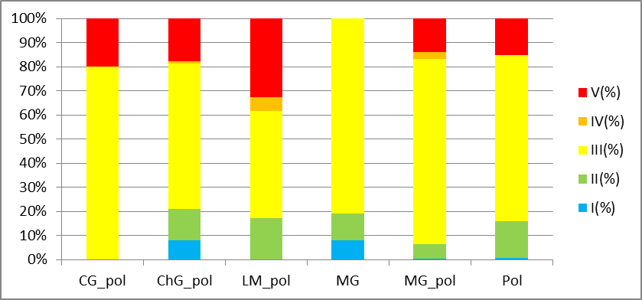
Figure 4.8 – Ratio of groups with different tolerance to the content of organic matter in the environment (CG_pol - Cerastoderma glaucum-Spio filicornis, ChG_pol - Chamelea gallina – Polychaeta varia, LM_pol - Lentidium mediterraneum – Polychaeta varia, MG - Mytilus galloprovincialis, MG_pol - Mytilus galloprovincialis - Alitta succinea, Pol – Polychaeta)

In 2021, there was a change in the ratio of the number of stations with GES/non-GES, so only 5% had a good environmental status, while previously about 40%. It should be noted that this ratio fluctuates greatly from year to year. For example, in 2014 it was 20%/80%, and in 2015, the contrary, it was 88 %/12 %. These indicators, among other things, are related to the temperature regime of the sea and the settling conditions of young bivalve mollusks.
In general, the benthic communities of the coastal zone of the PZCHM are quite dynamic compared to the communities of the deeper-water shelf zone. On the one hand, this is due to the dynamics of the surf substratum, on the other hand, to anthropogenic load and the concentration of organic substances in water and bottom sediments. The values of the integrated indicators of AMBI and M-AMBI environmental quality in 2021 are slightly lower than in 2019-2020. However, due to the limited number of observations, it is premature to speak of a general worsening trend at the moment.

Macrophytobenthos.
Compared to the entire Black Sea, the coastal parts of the NWBS have poor flora. As a result of studies of macrophytobenthos of the coastal parts of the Dnieper region, the Odesa Bay and the Dniester region, 42 species were found within the OMR: 40 benthic algae and 2 species of seagrasses, which belong to 4 divisions: Chlorophyta, Rhodophyta, Ochrophyta and Tracheophyta. This insignificant biodiversity is explained primarily by summer-autumn sampling and, as a result, the absence of seasonally winter and spring species.
In the conditions of increased eutrophication and some desalination of coastal water areas, green algae prevailed in all studied areas, from 5 to 9 species at different stations. In the second city, red algae - from 4 to 8 species. Water areas near the Port of Pivdenny (CW7) and Dacha of Kovalevskyi (CW5) are characterized by low biodiversity. Small epiphyte species were present in some water areas, which indicates the eutrophication of these areas. Thus, in the area of ​​the Port of Pivdenny, small Cladophora albida epiphytes diatoms with a very high specific surface area: the genus Diatoma (S/W 957,10±27,51 m²·kg⁻¹, the genus Navicula (S/W from 644,77 ± 36,63 m²·kg⁻¹ to 732,72 ± 17,57 m²·kg⁻¹.
In other water areas, macrophytes were slightly colonized by small epiphyte species of the genus Acrochaetium (S/W from 398,4 ± 14,5 m²·kg⁻¹ to 424,1 ± 12,1 m²·kg⁻¹) and the endophyte Ulvella leptochaete (S/W 427,2 ± 21,5 m²·kg⁻¹). The presence of a significant number of small epiphyte species, in addition, significantly increases the average ecological activity of species, which is inversely dependent on the quality of the marine environment (the more, the worse). Effective biomass at the existing projective coverage of 80% fluctuated slightly and decreased in autumn: from 0,700 kg∙m⁻² to 1,000 kg∙m⁻² in spring and from 0,500 kg ∙m⁻² to 0,900 kg∙m⁻² in autumn. According to ecological assessment indices (S/W)3Dp, S/W)x, a greater percentage of water areas can be classified as having a "very good" ecological state. The SIph indicator, which directly depends on biomass, is classified as "good". The presence of sensitive and tolerant species is important for assessing the ecological state. Large, perennial species with a low specific surface value are indicators of achieving good condition. A large number of significant biomass of small-branched species indicates a high level of eutrophication and low categories of ecological status classes. In coastal areas, the percentage of sensitive species of macroalgae such as Punctaria latifolia, Lomentaria clavellosa, Chaetomorpha linum and seagrasses - Zostera marina, Z.noltei, was low and amounted to about 11%, which does not correspond to a good ecological condition.
In autumn, red algae Chondria capillaris with S/Wp 28,6 ± 1,8 m²·kg⁻¹was found in 2 open areas of Luzanivka beach in storm emissions. The species is new to Odesa Bay. This species is characteristic of the Cystoseira barbata phytocenosis of the Tyligul estuary. Chondria capillaris is often an epiphyte on the thallus of char algae in the Tendrovskaya and Yahorlytskyi bays, within the water area of ​​the Dzharylgatskyi National Nature Park, in the water area of the Small Phyllophore Field in the Karkinitsky Bay. Until 2012, the association of Chondria tenuissima was noted closer to the seaside part of the Tuzlov estuaries.

Microphytobenthos.
In the microphytobenthos groups of hard and soft substrates of coastal sea masses, 158 species of algae were found - representatives of 8 divisions, among which diatoms predominated and numbered 106 species. Poly- and mesogalobous and β-mesosaprobic species of the genera Nitzschia, Navicula, Licmophora, Amphora and Halamphora dominated. The number of microphytes was primarily formed by small-celled blue-green algae, and the biomass by large-celled diatoms, among which Achnanthes brevipes, Licmophora gracilis, and Navicula pennata prevailed. The highest systematic and quantitative indicators of microphytobenthos development were characteristic of the most eutrophic water areas located near the Sanatorium named after Chkalova (CW5) and Koblevo (CW7). Potentially toxic cyanoprokaryotes Aphanizomenon flos-aquae, Dolichospermum flos-aquae and dinophytic algae Prorocentrum cordatum, Prorocentrum micans, Scrippsiella acuminata were found. In general, the condition of the microphytobenthos community improved in the summer and slightly worsened in the fall compared to 2020.

Assessment of the quality of the marine environment by biotesting methods of bioindication.
In 2021, the assessment and diagnosis of the ecological state of the environment of the water bodies of the PZCHM were carried out using the methods of biotesting and bioindication using physiological-morphological, systematic, quantitative, halobiont and saprobiont indicators of the development of test objects and indicator organisms of different systematic levels and sensitivities.
The ecological condition of the studied water areas was affected by both anthropogenic factors (recreational load, discharges of household, drainage and sanatorium effluents, port operations, etc.) and natural factors (temperature and salinity of water masses, storm phenomena and a number of others), which affected on the indicators of development of the applied test objects (adult mussels and their larvae, as well as model cultures of microalgae) and indicator organisms (microphytobenthos algae).
Based on the results of modelling the processes of the influence of extracted water pollutants and bottom sediments of the marine environment in laboratory conditions on the population of microalgae, it was established that the worst ecological properties for the life of hydrobionts were characterized by the surface layers of water of the CW5 massifs of Dacha Kovalevsky beach; CW 7 – Luzanivka beach and Yuzhny port. Toxic substances were also found in the surface waters of CW5 massifs - the Chkalov sanatorium; CW6 – Odesa port district (30.88-33.83% of the control); a water area of ​​CW7 beach – Koblevo and in the bottom sediments of CW4 - Zatoka beach. Bottom sediments in the maximum investigated concentrations of the area CW5 - Dolphin beach (23,70% of the control) had significant toxicity, and are characterized as belonging to the ecological class "lethal".
For the first time in 20 years of monitoring studies of the state of the Black Sea environment using the method of biotesting of water quality on mussel larvae, the above-mentioned environments of the areas of water bodies corresponding to the class of ecological status of waters "good", and all other investigated coastal areas of the sea - to the class "satisfactory".
Despite this, the autumn season of 2021 brought the deterioration of the quality of the coastal water environment of the PZCHM, for the most part, to the "satisfactory" state. And for a third of water areas - even to the "mediocre" state.
According to biotesting data on mussel larvae, the quality of the coastal waters of the PZCHM massifs (CW4-CW7) in the autumn season of 2021, on average, corresponded, as well as according to the Baseline assessment for the autumn periods of 2009-2018, to the class of ecological status "satisfactory". A comparison of the average assessment of indicators of the development of mussel larvae with normal morphology for the autumn season of 2021 (which amounted to 32,0%) indicates a 1,9-fold improvement in the ecological state of water bodies CW4-CW7 relative to the indicator of the determined Basic assessment of the quality of the environment of these areas of the sea (16,7% of morphologically normal test subjects).
During 2021, biotesting on larvae and adults of mussels and bioindication of water quality in the Dniester and Dnipro-Buzka districts of the NWBS revealed that the water area located near Cape Small Fontain (CW5) had, in general, the best ecological properties for the development of marine organisms, i.e. remained conditionally clean on the coast of Odesa.

5. Eutrophication

Range of variations of nutrients in different regions of UA national waters in 2021 are presented in Table 5.1 – 5.2 and corresponds pictures (Fig 5.1 – 5.5).

Table 5.1 - Range of variations of nutrients in the surface layer of UA national waters in 2021
 | PO₄  µM | P_{total}  µM | NH₄  µM | NO₂  µM | NO₃  µM | N_{total}  µM
Danube delta (May 2021)
Min | 0,28 | 0,81 | 0,30 | 0,45 | 14,1 | 62,4
Max | 1,11 | 1,92 | 2,01 | 0,87 | 91,3 | 211,6
Average | 0,58 | 1,23 | 0,94 | 0,62 | 46,0 | 109,6
Danube delta (October 2021)
Min | 0,23 | 1,17 | 0,33 | 0,08 | 2,01 | 10,4
Max | 2,40 | 4,65 | 4,20 | 1,25 | 71,8 | 142,2
Average | 1,16 | 2,13 | 1,64 | 0,56 | 24,1 | 73,3
Island Zmeinyi
Min | 0,10 | 0,10 | 0,14 | 0,21 | 0,00 | 15.2
Max | 0,52 | 2,62 | 2,57 | 1,57 | 4,78 | 37,4
Average | 0,23 | 0,86 | 0,91 | 0,43 | 0,90 | 26,2

Table 5.2 - Range of variations of nutrients in the bottom layer* of UA national waters in 2021
 | PO₄  µM | P_{total}  µM | NH₄  µM | NO₂  µM | NO₃  µM | N_{total}  µM
Danube delta (May 2021) ¹
Min | 0,18 | 0,78 | 0,00 | 0,10 | 6,33 | 43,4
Max | 1,09 | 1,79 | 4,30 | 0,84 | 108,6 | 322,6
Average | 0,47 | 1,11 | 0,77 | 0,41 | 25,7 | 115,1
Danube delta (October 2021) ²
Min | 0,20 | 0,75 | 0,00 | 0,07 | 0,95 | 15,6
Max | 1,95 | 2,80 | 2,90 | 1,21 | 66,5 | 143,9
Average | 0,53 | 1,42 | 0,76 | 0,32 | 14,9 | 54,1
Island Zmeinyi³ 2018
Min | 0.10 | 0.26 | 0.14 | 0.07 | 0.07 | 17.9
Max | 0.61 | 1.26 | 3.93 | 2.78 | 4.64 | 54.3
Average | 0.27 | 0.77 | 1.75 | 0.65 | 1.33 | 30.9
¹ On the depth 4,0 - 25,0 m
² On the depth 4,5 m - 23,5 m
³ On the depth 8 m

According to long-term observations in 2000-2021 in the coastal water body СW5 of the Odessa region of the Black Sea there is a tendency to decrease the mineral (DIP) and total phosphorus (TP). The average annual content of mineral phosphorus in this period varied from 23,9 μg/dm³, at the beginning of the XXI century, to 9,3 μg/dm³ in 2015 (Fig. 5.1). In the last five years, the average annual content of mineral phosphorus in coastal waters in this area has ranged from 10,6 μg/dm³ to 14,9 μg dm³, with an average of 12,8 μg/dm³. The level of average annual values of the concentration of mineral phosphorus in the recreational zone of the water body СW5 corresponds to a good ecological condition at the value of GES 16,4 μg/dm³.

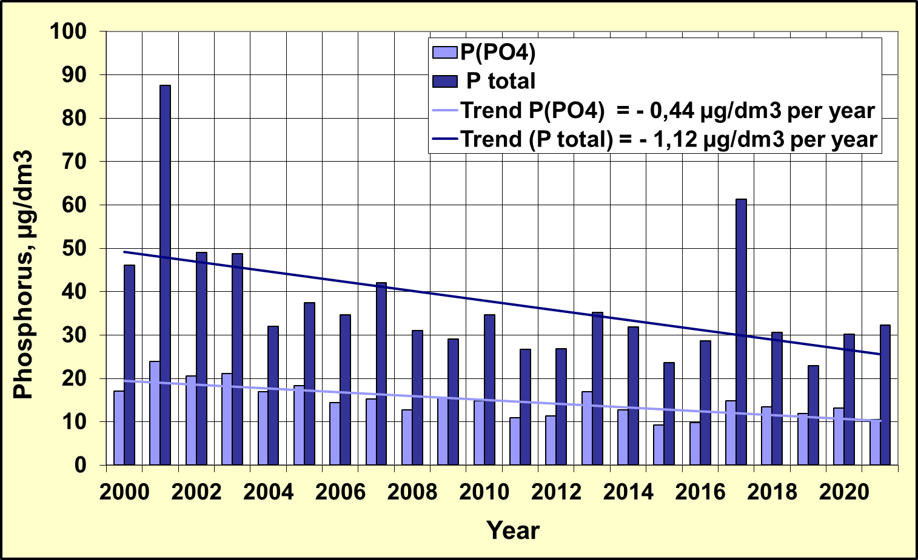
Figure 5.1 - Long-term changes in the content of mineral and total phosphorus in the coastal water body CW5 in the recreational zone of the city of Odessa

In the multi-year plan of 2000 - 2021, the content of the average annual amount of mineral forms of nitrogen (DIN) in the coastal water body СW5 of the Black Sea shows a tendency to decrease its concentration from 182,9 μg/dm³ in 2001 to 85,9 μg/dm³ in 2021. (Fig. 5.2). In the last five years, the average annual mineral nitrogen (DIN) content ranged from 47,7 μg/dm³ to 85,9 μg/dm³, with an average value of 66,5 μg/dm³. In 2021, according to the average annual DIN concentration, coastal waters in this area not corresponded to GES 52,7 μg/dm³. The general tendency to decrease the DIN content in the period 2000 - 2021 was -3,45 μg/dm³ per year.

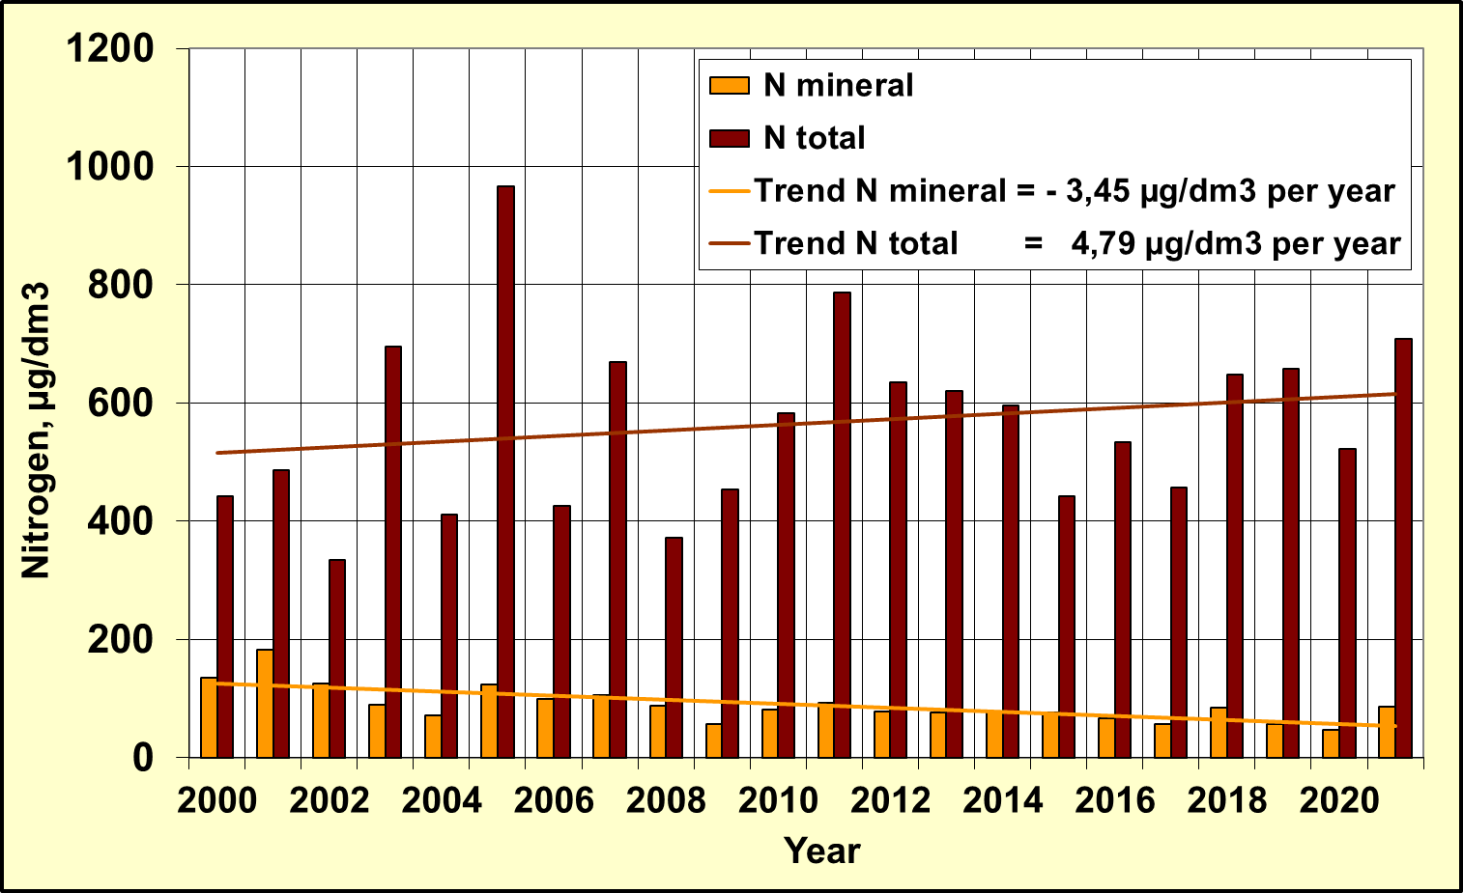
Figure 5.2 - Long-term changes in mineral and total nitrogen content
in the coastal water body СW5 in the recreational zone of the city of Odessa

The tendency to decrease the content of mineral compounds of nitrogen is determined by its individual indicators of nitrite, nitrate and ammonium nitrogen, which is shown in Figure 5.3.

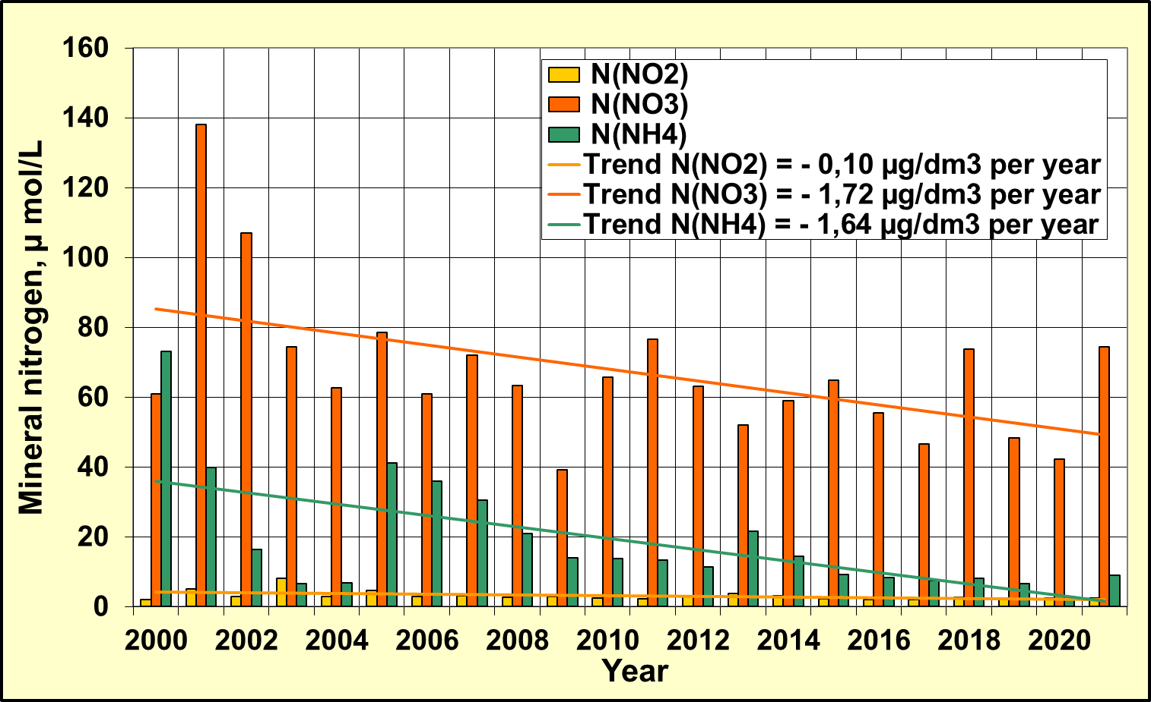
Figure 5.3 - Long-term changes in the content of mineral forms of nitrogen in the coastal water body СW5 in the recreational zone of the city of Odessa

In areas distant from industrial zones, in 2021, trophicity of coastal waters, according to the average annual value of the TRIX index (5,2 units), corresponded to the "moderate" level (Fig. 5.4).
In the long-term variability of the trophicity indicator in the coastal waters of the recreation zone in the Odessa region there is a tendency of decreasing and some improvement in the quality of marine coastal waters, comparing with the beginning of the 2000s. The linear trend of the index of trophic index of TRIX index has the angular coefficient of – 0,039 units per year.

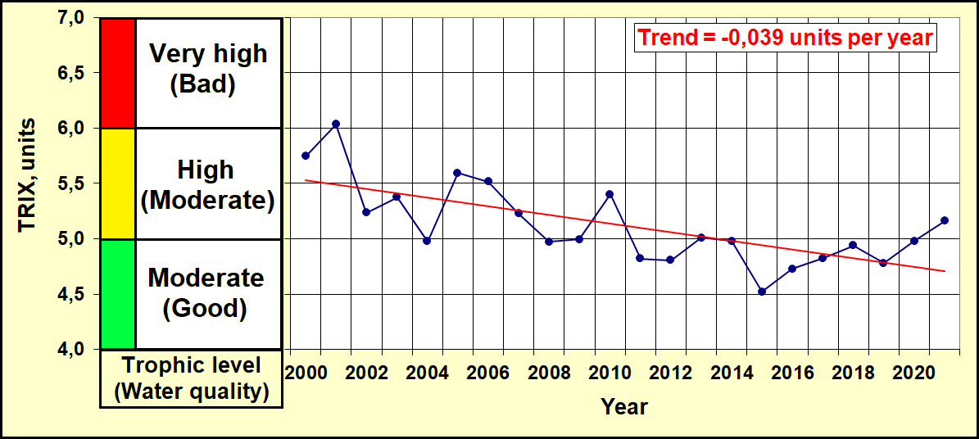
Figure 5.4 – The long-term changes of trophicity and quality of the coastal waters
of Odessa region of NWBS by TRIX index

6. Other activities of the RAC PMA

6.1 Overview of monitoring data flows to the RDB-P by Ukraine in 2021 years

Table 6.1 Statistics of the sample types by years
 |  | 2010 | 2011 | 2012 | 2013 | 2014 | 2015 | 2016 | 2017 | 2018 | 2019 | 2020 | 2021
Ukraine | BathingWater | - | - | - | - | - | - | - | - | - | - | - | -
Ukraine | Biota | - | - | + | + | + | + | + | + | + | + | + | -
Ukraine | Sediment | + | + | + | + | + | + | + | + | + | + | + | +
Ukraine | Water | + | + | + | + | + | + | + | + | + | + | + | +

Table 6.2 Statistics of the number of parameter groups by years (water, sediment, biota)
Ukraine |  |  | SampleType-Water
ParameterGroup/Year | 2010 | 2011 |  | 2012 | 2013 | 2014 | 2015 | 2016 | 2017 | 2018 | 2019 | 2020 | 2021
Detergents | 1 | 1 |  | 1 |  | 1
Hydrochemistry | 7 | 7 |  | 6 | 6 | 6 | 6 | 7 | 7 | 7 | 7 | 6 | 6
Hydrology | 2 | 2 |  | 2 | 2 | 2 | 2 | 2 | 2 | 2 | 2 | 2 | 2
Nutrients | 7 | 7 |  | 7 | 7 | 7 | 7 | 7 | 7 | 7 | 7 | 7 | 7
PAHs | 17 | 1 |  | 16 |  |  |  | 16 | 17 | 17 | 18 | 18 | 18
PCBs | 11 | 19 |  | 22 | 19 | 19 | 22 | 23 | 23 | 23 | 32 | 26 | 34
Pesticides | 13 | 13 |  | 11 | 13 | 13 | 12 | 12 | 12 | 12 | 14 | 14 | 14
Petroleum Hydrocarbons | 1 | 1 |  | 1 | 1 | 1 | 1 | 1 | 1 |  | 1
Phenols | 1 | 1
Photosynthetic pigments |  |  |  | 1
Radionuclides | 1
Trace (heavy) metals | 10 | 11 |  | 11 | 11 | 11 | 10 | 11 | 10 | 10 | 10 | 10 | 10

Ukraine | SampleType- sediment
ParameterGroup/Year | 2010 | 2011 | 2012 | 2013 | 2014 | 2015 | 2016 | 2017 | 2018 | 2019 | 2020 | 2021
Detergents
Hydrochemistry |  | 2 | 2 | 2 | 2 | 2 | 2 | 2 | 2 |  |  | 2
Nutrients
PAHs | 17 | 17 | 17 |  |  |  | 16 | 17 | 17 | 18 | 18 | 18
PCBs | 9 | 12 | 22 | 20 | 19 | 21 | 23 | 23 | 31 | 32 | 26 | 34
Pesticides | 13 | 11 | 11 | 13 | 11 | 12 | 12 | 12 | 12 | 14 | 14 | 14
Petroleum Hydrocarbons | 1 | 1 | 1 | 1 | 1 | 1 | 1 | 1 | 1 | 1 | 1 | 1
Phenols | 1 | 1 | 1 | 1 | 1 | 1 | 1 | 1 | 1 | 1 | 1 | 1
Radionuclides
Trace (heavy) metals | 11 | 11 | 12 | 11 | 12 | 10 | 12 | 12 | 11 | 12 | 11 | 12

Ukraine | SampleType-Biota
ParameterGroup/Year | 2012 | 2013 | 2014 | 2015 | 2016 | 2017 | 2018 | 2019 | 2020 | 2021
PCBs | 20 | 19 | 20 | 23 | 23 | 23 | 30 | 31 | 26 | -
Pesticides | 11 | 11 | 11 | 12 | 12 | 12 | 12 | 14 | 14 | -
Trace (heavy) metals | 11 | 10 | 11 | 10 | 11 | 11 | 11 | 11 | 11 | -
PAHs |  |  |  |  | 16 | 16 | 16 | 17 | 18 | -
Table 6.3 – Statistics of the number of samples by parameter groups and by years (water)

Ukraine | SampleType-Water
ParameterGroup/  Year | 2010 | 2011 | 2012 | 2013 | 2014 | 2015 | 2016 | 2017 | 2018 | 2019 | 2020 | 2021
Detergents | 72 | 219 | 10 |  | 10
Hydrochemistry | 1190 | 1596 | 1245 | 333 | 210 | 204 | 560 | 807 | 189 | 530 | 204 | 316
Hydrology | 292 | 371 | 665 | 134 | 212 | 312 | 302 | 409 | 48 | 275 | 124 | 168
Nutrients | 1369 | 2203 | 778 | 399 | 646 | 678 | 999 | 1337 | 288 | 957 | 396 | 552
PAHs | 34 | 7 | 208 |  |  |  | 889 | 1564 | 867 | 1422 | 432 | 486
PCBs | 42 | 365 | 831 | 384 | 342 | 657 | 1357 | 2139 | 1179 | 2560 | 624 | 1632
Pesticides | 52 | 235 | 401 | 235 | 214 | 346 | 708 | 1116 | 612 | 1120 | 336 | 630
Petroleum Hydrocarbons | 159 | 299 | 39 | 27 | 18 | 4 | 61 | 64 |  | 30 |  | 24
Phenols | 149 | 168 | 15
Radionuclides | 7
Trace (heavy) metals | 112 | 492 | 433 | 194 | 180 | 480 | 525 | 990 | 509 | 780 | 240 | 480

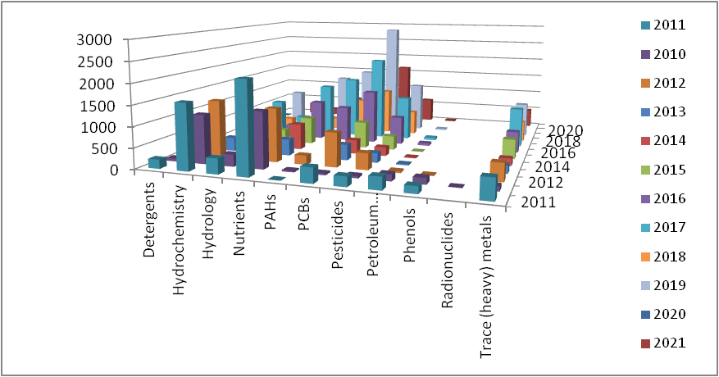
Figure 6.1 - Distribution of the number of samples by parameter groups and years (water)

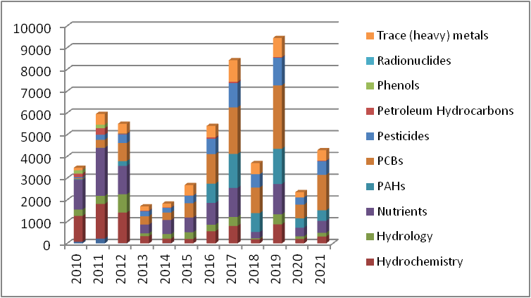
Figure 6.2 - Total numberof samples for each parameters group (water)

Table 6.4 – Statistics of the number of samples by parameter groups and by years (sediment)

Ukraine | SampleType- sediment
ParameterGroup/  Year | 2010 | 2011 | 2012 | 2013 | 2014 | 2015 | 2016 | 2017 | 2018 | 2019 | 2020 | 2021
Hydrochemistry |  | 84 | 41 | 34 | 20 | 56 | 64 | 88 | 24 |  |  | 48
PAHs | 204 | 289 | 374 |  |  |  | 416 | 833 | 442 | 702 | 216 | 198
PCBs | 32 | 489 | 707 | 723 | 266 | 684 | 621 | 1081 | 614 | 1344 | 312 | 888
Pesticides | 52 | 495 | 350 | 415 | 154 | 359 | 324 | 564 | 312 | 582 | 168 | 310
Petroleum Hydrocarbons | 47 | 45 | 43 | 37 | 15 | 26 | 39 | 49 | 24 | 24 | 12 | 24
Phenols | 43 | 42 | 41 | 34 | 10 | 19 | 39 | 44 | 24 | 39 | 12 | 24
Radionuclides |  |  | 4
Trace (heavy) metals | 300 | 492 | 422 | 352 | 180 | 330 | 348 | 588 | 312 | 504 | 132 | 288

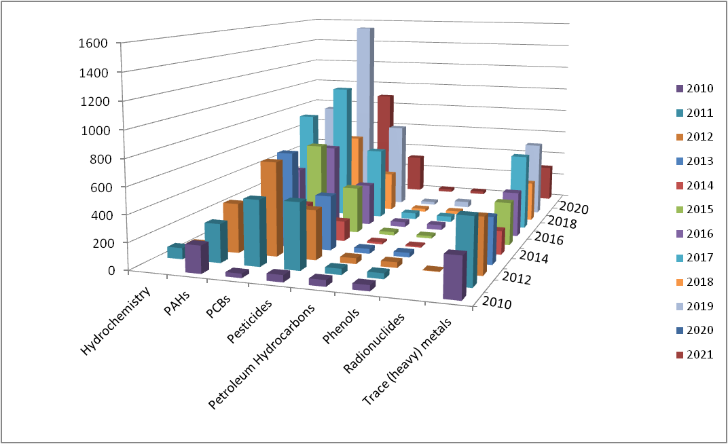

Figure 6.3 - Distribution of the number of samples by parameter groups and years (sediment)

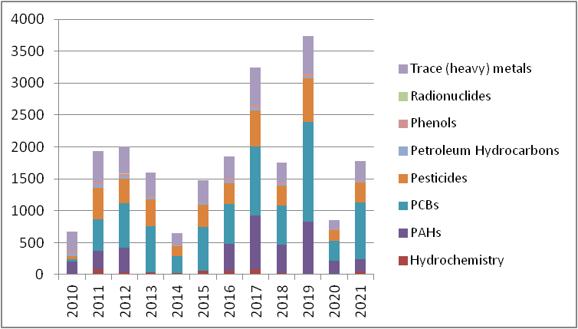
Figure 6.4 - Total number of samples for each parameters group (sediment)

Table 6.5 – Statistics of the number of samples by parameter groups and by years (biota)

Ukraine |  | SampleType-Biota
ParameterGroup/Year | 2012 | 2013 | 2014 | 2015 | 2016 | 2017 | 2018 | 2019 | 2020 | 2021
PCBs | 160 | 361 | 320 | 128 | 414 | 529 | 120 | 186 | 234
Pesticides | 88 | 209 | 176 | 69 | 216 | 276 | 48 | 84 | 126
Trace (heavy) metals | 106 | 193 | 176 | 70 | 190 | 242 | 44 | 77 | 121
PAHs |  |  |  |  | 288 | 368 | 64 | 102 | 162

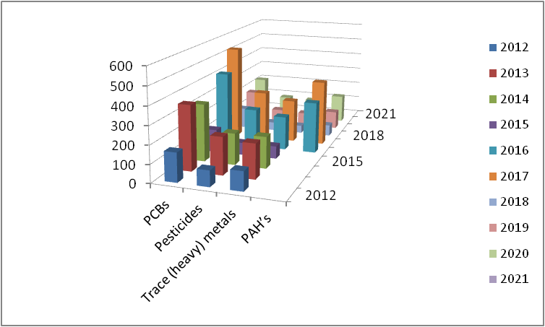
Figure 6.5 - Distribution of the number of samples by parameter groups and years (biota)

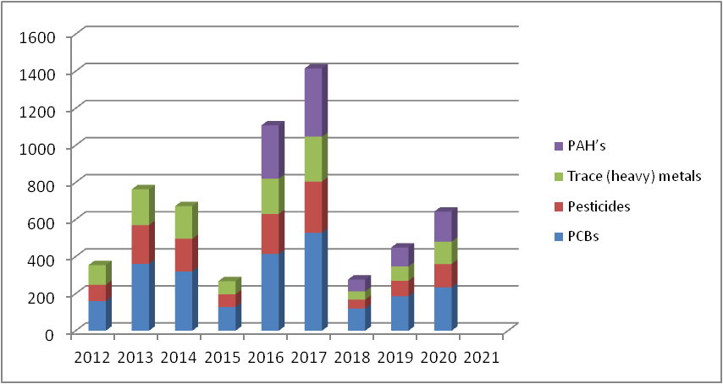
Figure 6.6 - Total number of samples for each parameters group (biota)

